**Software Requirement Specification**

**Project: Home Services Application**

**Version no. 1.0**

|  |  |
| --- | --- |
| **Document Control Sheet** |  |
| Current Version | 1.0 |
| Project Code | SRS_ HSA_13052018 |
| Project Name | Development of Mobile App and Web Based Backend Panel for Home Services |
| Document Type | SRS (Software Requirement Specification) |
| Author | Swanand |
| Reviewed By | Sameer |
| Frequency of Document Review | Next Revision of Standards Documents |
| Document Creation Date | 13 -05-2018 |
| Document Last Updated | 13 -05-2018 |

|  |  |  |  |
| --- | --- | --- | --- |
| **Revision History** | |  |  |
| **Version** | **Date** | **Author Name** | **Reviewer Name** |
| 1.0 | 13-05-2018 | Swanand | Sameer |

**Table of Contents**

1. Purpose of this document 3

2. Scope of Work 3

3. Abbreviations 4

4. User Roles 4

5. Functional Requirements 5

5.1. Customer 5

5.1.1. Splash Screen 5

5.1.2. Post Splash Screen 6

5.1.3. Login Screen 8

5.1.4. Signup Screen 11

5.1.5. Dashboard Screen 15

5.1.6. Sub-Category Screen 18

5.1.7. Create Request Screen 19

5.1.8. Acceptance & Tracking Screen 25

5.1.9. My Task Screen 28

5.1.10. My Profile Screen 42

5.1.11. FAQ Screen 51

5.1.12. Contact Us Screen 52

5.1.13. Refer Friend 54

5.1.14. Notifications 56

5.2. Service Provider 57

5.2.1. Splash Screen 57

5.2.2. Login Screen 58

5.2.3. Dashboard/My Tasks Screen 61

5.2.4. My Profile Screen 77

5.2.5. Statistics Screen 81

5.2.6. FAQ Screen 82

5.2.7. Contact Us Screen 83

5.2.8. Refer Friend 85

5.2.9. Notifications 87

5.3. Administrator 88

5.3.1. Login 88

5.3.2. Dashboard 90

5.3.3. Manage Customers 92

5.3.4. Manage user 96

5.3.5. Manage Service Request 101

5.3.6. Manage Category 105

5.3.7. Manage Sub-Category 109

5.3.8. Manage FAQ’s 113

5.3.9. Manage Promo Code 117

5.3.10. Manage Query/Suggestion 121

5.3.11. Notifications 124

5.3.12. Manage Roles 127

5.3.13. Reports 131

6. ASSUMPTIONS 136

7. CONSTRAINTS 136

8. NON FUNCTIONAL REQUIRMENTS 137

8.1. Technical Specifications 137

8.2. Technology Details: 137

8.3. Operating Environment 137

8.4. Communication Interface 137

8.5. Performance Requirements 138

8.6. Security Requirements 138

8.7. Portability Requirements 138

8.8. GREY AREAS 139

8.9. Process Flow Diagrams 140

8.9.1. Functional Flow 140

8.10. Supported gateways: 141

# Purpose of this document

This document specifies the software requirements for the Home Services Mobile application. This document helps the business stakeholders to understand what to expect out of the project & technical stakeholders to understand what needs to be delivered.

The System Requirements Specification will:

* Define the scope of business objectives, business functions and organizational units covered for the project.
* Identify the business processes that the solution must facilitate.
* Facilitate a common understanding of what the software requirements are for all parties involved in the project.
* Establish a basis for defining the acceptance tests for the solution to confirm that what is delivered meets requirements.

**Summary:**

Client is looking for a Home Services mobile application which will be a one-step solution to all household woes of their customers. Services of this application will include range of help services that are aimed at making lives easy. The application to be developed will help book services and get it done by experienced professionals. The help services are provided at convenient time selected by the customer, as the application is intended to provide best services at best time.

The mobile application to be developed will be used by the customers and service providers. To support and manage the mobile application a web based backend will be developed which will be used by the administrator of the application.

The detailed scope of mobile as well as web based backend is mentioned below in this document.

**Mobile app Design & Wireframe approved by client**

* Customer mobile app: <http://wireframes.php-dev.in/Swanand/Home_Services/Customer/>
* Service Provider mobile app: <http://wireframes.php-dev.in/Swanand/Home_Services/Service%20Provider/>
* Administrator: <http://wireframes.php-dev.in/Swanand/Home_Services/Admin/>

# Scope of Work

|  |
| --- |
| **In Scope** |
| Mobile Application for Customer |
| Mobile Application for Service Provider |
| Web based application for Administrator |
| Web Services |

# Abbreviations

|  |  |
| --- | --- |
| **Abbreviations** | |
| OTP | One Time Password |

# User Roles

|  |  |  |  |
| --- | --- | --- | --- |
| **User Role** | **Role Description** | **Device** | **End user capacity** |
| Customer | Customer will be able to create new request, cancel request, accept quote, reject quote, make payments to service provider and giver reviews against service provider. | Mobile Application | Unlimited |
| Service Provider | Service Provider will be able to accept the requests from customer, reject requests, manage tasks and receive payments. | Mobile Application | Unlimited |
| Administrator | Administrator will be able to manage customers, manage service providers, manage requests, manage categories, manage service requests and generate reports | Web based Application | Unlimited |

# Functional Requirements

This section caters the functional requirements of the Home Services Mobile App & Web Panel–

## Customer

### Splash Screen



*Figure 1 Splash Screen*

|  |  |  |
| --- | --- | --- |
| Actor(s) involved | Customer | |
| Requirement definition | Customer will be able to view the splash screen at the launch of application on their mobile device. | |
| Pre-condition | Customer should have the application installed on their device and has launched the application. | |
| Post-condition | Customer will be able to view the splash screen for 10 seconds. | |
| Business process flow/Business Rules | Customer will be able to view the splash screen for 10 seconds and then they will be redirected to the post splash screen which is explained in detail below. | |
| Field validation |  | |
|  |  |  |

### Post Splash Screen

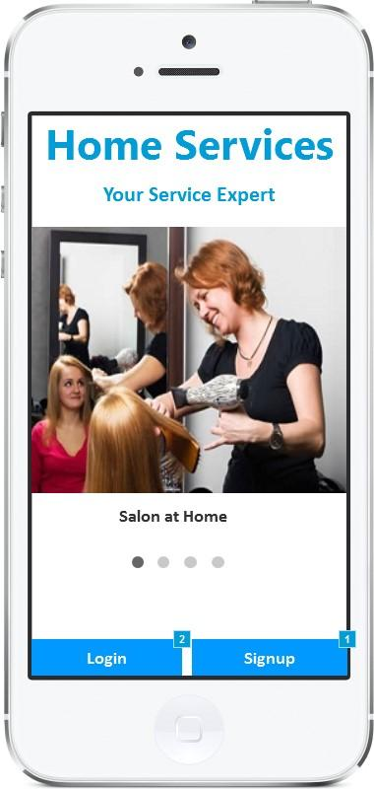

*Figure 2 Post-Splash Screen*

|  |  |  |
| --- | --- | --- |
| Actor(s) involved | Customer | |
| Requirement definition | Customer will be able to view the post splash screen and choose to either login or signup. | |
| Pre-condition | Customer has launched the application on their mobile device. | |
| Post-condition | Customer will be able to view the banner slider and choose to either login or signup | |
| Business process flow/Business Rules | Customer will be able to view the banner slider and choose to either login/signup on the application.  Banner slider will show 5 images related to the services provided by the application.  Selecting the login button will navigate the customer to the login screen. Selecting the signup button will navigate the customer to the signup screen. | |
| Field validation |  | |
|  |  | |
|  | Login | Button |
|  | Signup | Button |

### Login Screen

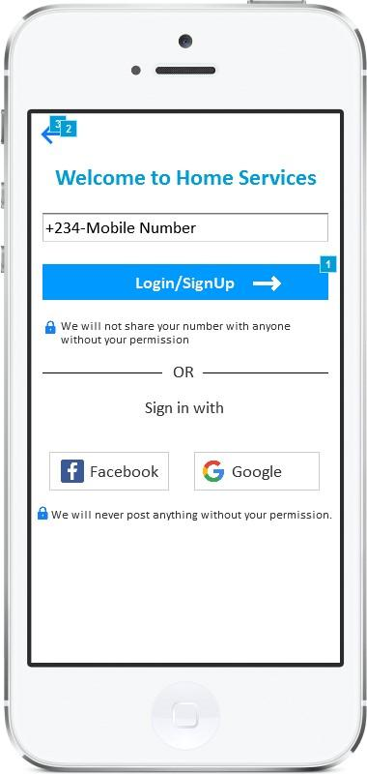

*Figure 3 Login Screen*

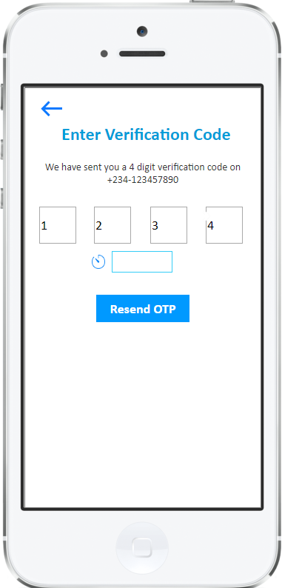

*Figure 4 OTP Screen*

|  |  |  |
| --- | --- | --- |
| Actor(s) involved | Customer | |
| Requirement definition | Customer will be able to login into the application | |
| Pre-condition | Customer has selected “Login” button on the post-splash screen. | |
| Post-condition | Customer will be navigated to the dashboard screen. | |
| Business process flow/Business Rules | Customer will login into the mobile application by 2 ways which are as follows:   1. Mobile Number    1. Customers will be able to login using their mobile number by entering their mobile number in the provided field and then clicking “Login” button.    2. Clicking the login button will send One Time Password (OTP) to customer mobile number via SMS.    3. Entering the OTP back into the mobile application will login the customer into the application. (In case of Android phones the OTP received via SMS will be auto-detected and filled in the OTP field. A standard SMS format will be created for easy detection). 2. Social Connect    1. Customer will be able to login using the social connect feature of Google+ and Facebook. This feature will allow the customer to enter their social media credentials like username and password to login into the application. Social connect feature will check the mobile number of customer, if mobile number is not available then customer will be asked to enter mobile number separately. (As social connect feature restricts sharing of some details).    2. Social connect feature will fetch the basic details of the customer like “First Name, Last Name, Email and Phone Number”. | |
| Field validation |  | |
|  |  | |
|  | Mobile Number | Text Field |
|  | OTP | Text Field |
|  | Login | Button |
|  | Signup | Button |
|  | Resend OTP | Button |
|  | Signup using Facebook | Button |
|  | Signup using Google | Button |

### Signup Screen

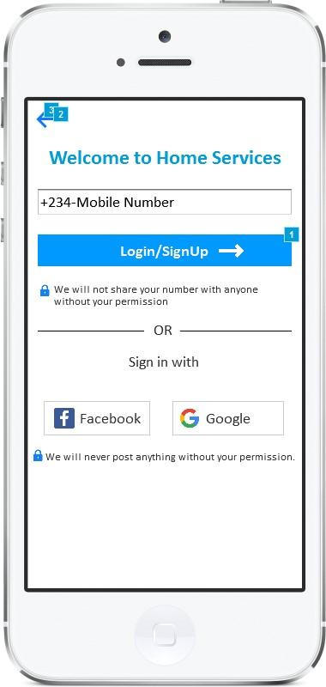

*Figure 5 Signup Screen*

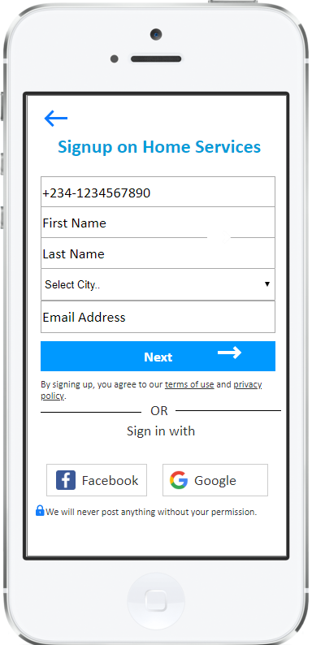

*Figure 6 Signup Details Screen*

|  |  |  |
| --- | --- | --- |
| Actor(s) involved | Customer | |
| Requirement definition | Customer will be able to sign up on the mobile application. | |
| Pre-condition | Customer has selected “Signup” button on the post-splash screen. | |
| Post-condition | Customer will be signed up and navigated to the login screen | |
| Business process flow/Business Rules | Customer will be able to sign up on the mobile application using either custom registration feature or by using the social connect feature. Both registration features are explained in detail below.   1. Custom Registration    1. Customer will be able to sign up on the mobile app in 2 steps which are as follows:       1. Mobile Number Verification (Step 1)          1. Since mobile number is primary mode of communication the customers will need to verify the mobile number in step 1.          2. To verify mobile number customer will need to enter their mobile number in the provided field and then click “Login” button.          3. Clicking the login button will send One Time Password (OTP) to customer mobile number via SMS.          4. Entering the OTP back into the mobile application will navigate the customer to signup details screen which is explained below.       2. Signup Details (Step 2)          1. After verification of mobile number customer will enter following details in signup details screen “First name, Last Name, City and Email Address”.          2. Entering the details will sign up the customer and navigate them to the login screen. 2. Social Connect    1. Customer will be able to sign up using the social connect feature of Google+ and Facebook. This feature will allow the customer to enter their social media credentials like username and password to sign up into the application. This feature will avoid valuable time of customer by automatically fetching the details from Google/Facebook mentioned in the “Signup Details” screen.    2. Social connect feature will check the mobile number of customer, if mobile number is not available on social media sites then customer will be asked to enter mobile number separately. (As social connect feature restricts sharing of some details).    3. Social connect feature will fetch the basic details of the customer like “First Name, Last Name, Email and Phone Number”. | |
|  | **Validation 1 ( OTP Verification):**  The OTP sent to the customer mobile number should match with the value in the database. The OTP will be generated in random order and will be managed in the backend of the application. If the OTP entered by the customer does not match the value in the database then application will show following error “Entered OTP is not correct. Please enter the Correct OTP”.  **Validation 2 (Resend OTP):**  In case the OTP is not received by the customer due to network issues, customer can request another OTP by clicking “Resend OTP” button as shown in figure 4.  **Validation 3 (Duplicate User):**  The mobile number entered by the customer will be checked for duplicity. If the entered mobile number matches with mobile number of any other user in the database then following error will be shown “ Entered mobile number already exists, please enter different number”. | |
|  |  | |
|  | Mobile Number | Text Field |
|  | First Name | Text Field |
|  | Last Name | Text Field |
|  | City | Dropdown |
|  | Email | Text Field |
|  | Signup using Facebook | Button |
|  | Signup using Google | Button |
|  | Next | Button |
|  | Signup | Button |
|  | Resend OTP | Button |

### Dashboard Screen

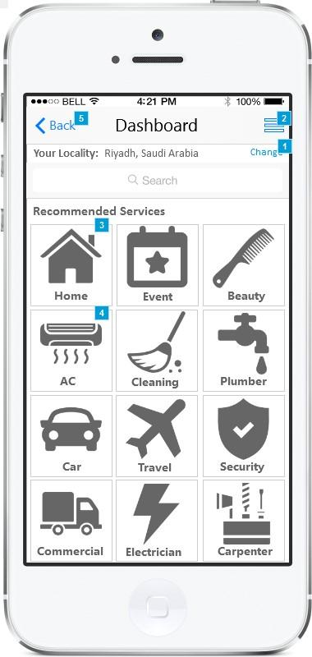

*Figure 7 Dashboard Screen*

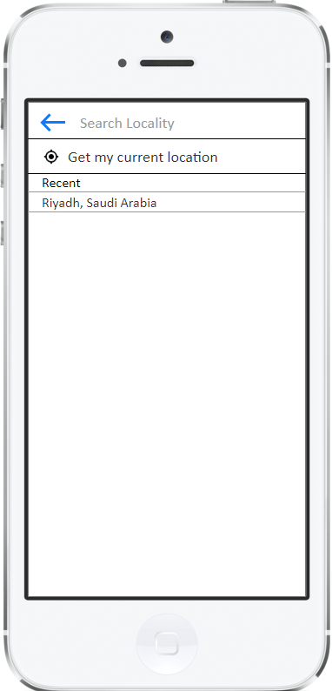

*Figure 8 Location Screen*

|  |  |  |
| --- | --- | --- |
| Actor(s) involved | Customer | |
| Requirement definition | Customer will be able to view the dashboard screen and will be able to browse different categories of service. | |
| Pre-condition | Customer is successfully logged into the application | |
| Post-condition | Customer will be able to view the dashboard and navigate to different categories as well as pages. | |
| Business process flow/Business Rules | The dashboard screen will be divided into 2 sections which are as follows:   1. Location Section    1. Customer will be able to view their current location in this section. The location of customer will be auto-detected using the GPS of the device. Application will show alert to turn-on the GPS if it’s not turned on.    2. The location feature will allow the customer to change their location manually by selecting the “Change” link and then entering the name of location. The location field will have auto-complete feature using the Google Places API. (As shown in figure 8.      1. Categories Section    1. This section will show the categories in grid format where each grid item will show thumbnail image/icon and text as shown in figure 7.    2. Customers will be able to quickly find any desired category by entering the category name in provided search field. The search field will have “Type to Search/Incremental Search” feature (Type to search/incremental search feature gives instant results as the user enters each letter).    3. Customer can create any service request by selecting any category. Selecting any category name will navigate the customer to sub-category page which is explained in detail below. | |
|  | **Validation 1 ( Location):**  The location feature will provide suggestion to the customer as they type in to the location field. The suggestion is given using the Google Places API. If any location is not found matching the letters entered by customer then following error will be shown “No location found, please enter name correctly”.  **Validation 2 (Category Search):**  The category search will be an incremental search and show the category names as per letters entered. If any category is not found then customers will be shown with following error “No matching categories found, please enter the name correctly”. | |
|  |  | |
|  | Back | Button |
|  | Side Menu | Button |
|  | Change | Button |
|  | Search | Text Field |
|  | Location | Text Field |

### Sub-Category Screen

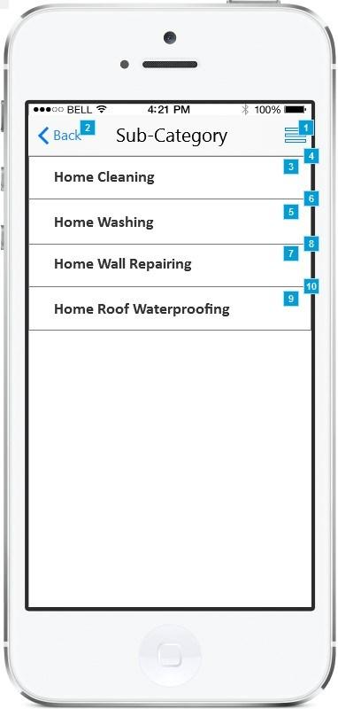

*Figure 9 Sub-Category Screen*

|  |  |  |
| --- | --- | --- |
| Actor(s) involved | Customer | |
| Requirement definition | Customer will be able to view the sub-category screen and will be able to select it for creating the service request. | |
| Pre-condition | Customer is successfully logged into the application and has selected category from the dashboard. | |
| Post-condition | Customer will be able to select the sub-category and create service request. | |
| Business process flow/Business Rules | Sub-category screen will show the list of sub-categories included within the selected category as shown in figure 9. Selecting any sub-category will navigate the customer to the Create Request screen which is explained in detail below. | |
|  |  | |
|  |  | |
|  | Back | Button |
|  | Side Menu | Button |

### Create Request Screen

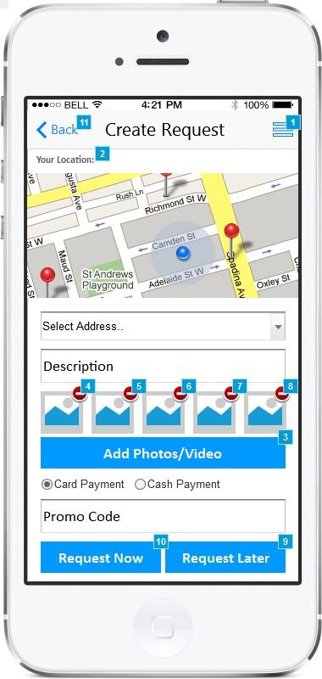

*Figure 10 Create Request Screen*

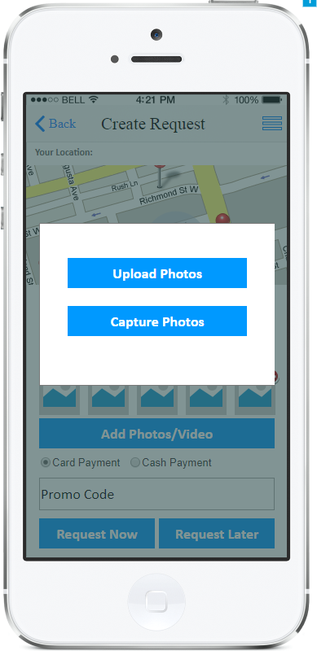

*Figure 11 Upload Image Screen*

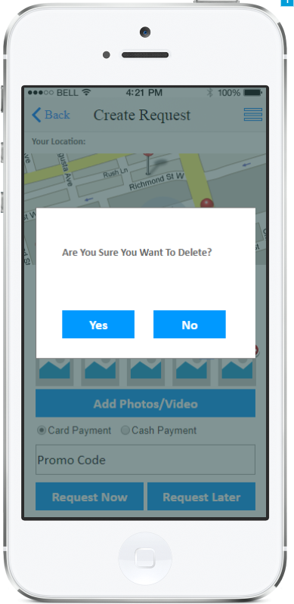

*Figure 12 Delete Image Screen*

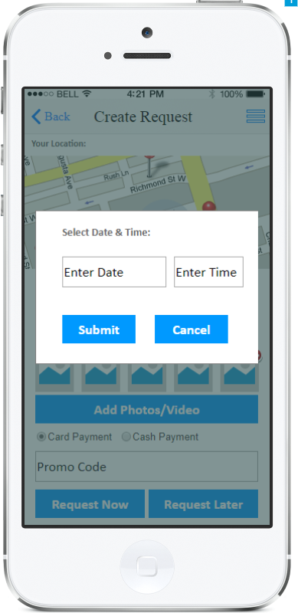

*Figure 13 Request Later Screen*

|  |  |  |
| --- | --- | --- |
| Actor(s) involved | Customer | |
| Requirement definition | Customer will be able to create service request. | |
| Pre-condition | Customer is successfully logged into the application and selected the sub-category. | |
| Post-condition | Customer will be able to create instant service request or schedule service request at any specified date. | |
| Business process flow/Business Rules | The create request screen will be divided into multiple sections which are as follows:   1. Location Section    1. Customer will be able to view their current location in this section. The location of customer will be auto-detected using the GPS of the device. Application will show alert to turn-on the GPS if it’s not turned on.    2. The location feature will allow the customer to change their location manually by selecting the address from the dropdown menu. Customer will be able to select the address they have added already using the my profile section.    3. Selected location/address will be used as destination for the service provider      1. Request Section    1. This section will allow the customer to enter the details related to the task. Customer can enter following details:       1. Description          1. Customer can enter description related to the service. Its free text field.       2. Images/Video          1. Customers can add/delete images and videos specific to the request as shown in figure 11 and 12. Customer can upload maximum 5 images and video of 10 seconds. For example, customer can upload photos of rooms within home when requesting for home cleaning service.       3. Type of Payment          1. Customers can choose the mode of payment they wish to pay for the services.       4. Promo Code          1. This section will allow the customer to enter any promotional code for availing any discount.    2. After entering the above details mentioned in location and request section customer will be able to request for service immediately or anytime later by clicking “Request Now” or Request Later” button respectively.    3. Clicking the Request now button will send service request to service providers within selected category and navigate the customer to the acceptance screen. Service request will be sent to the service providers within 10 km radius. The request assignment and acceptance logic is explained below in details.    4. Clicking the Request later will allow the customer to enter the date and time they wish to avail the service as shown in figure 13. In this case the request will be sent to service providers in the background and service provider will be assigned as per acceptance criteria explained below.    5. Creating any request will generate unique Order/Service ID for each request. | |
|  | **Validation 1 ( Promo Code):**  The promo code entered will be validated from the database. If the promo code entered is wrong or expired then following error will be shown “Please enter valid promo code”. If the promo code is valid then the discount will be shown on the toast message.  **Validation 2 (Date & Time):**  The date and time selected by the customer should be later than the current date and time. If the date and time entered is past the current date and time then following error will be shown “Please enter correct date and time”. | |
|  |  | |
|  | Back | Button |
|  | Side Menu | Button |
|  | Address | Dropdown |
|  | Description | Text Area |
|  | Add Photos/Videos | Button |
|  | Payment Type (Credit Card/Cash) | Radio Button |
|  | Promo Code | Text Field |
|  | Request Now | Button |
|  | Request Later | Button |
|  | Submit | Button |
|  | Cancel | Button |

### Acceptance & Tracking Screen

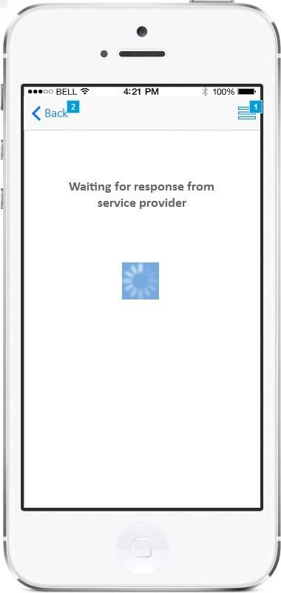

*Figure 14 Acceptance Screen*

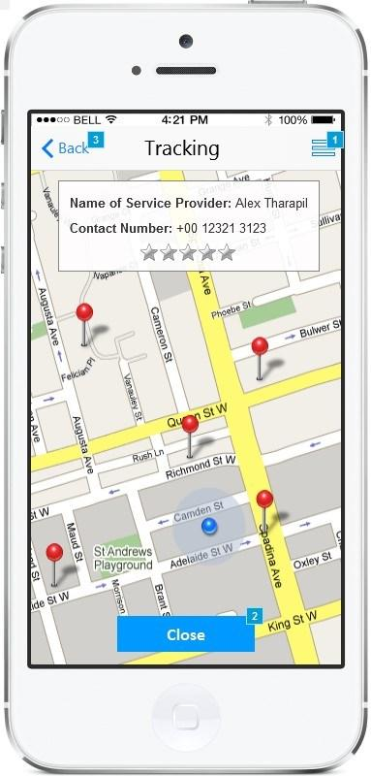

*Figure 15 Tracking Screen*

|  |  |  |
| --- | --- | --- |
| Actor(s) involved | Customer | |
| Requirement definition | Customer will be able to view the service provider details. | |
| Pre-condition | Customer is successfully logged into the application and requested for service immediately by clicking “Request Now” button. | |
| Post-condition | Customer will be able to view the details of service provider accepting their request. | |
| Business process flow/Business Rules | Customer will be navigated to the acceptance screen once they click on “Request Now” button on create request screen (explained above). The acceptance screen will be shown for 60 seconds. The acceptance screen will allow the service providers to accept the request raised by the customer using their mobile application.  If any service provider accepts the request, customer will be able to view their details and location on the map as shown in figure 15. Customer will be able to track the service provider live using the map. Along with tracking the customer will be able to view service provider details like “Name, Phone Number and Average Rating given by other customers”.  If customer clicks on the “Request Later” button on create request screen then same process explained above will be carried out in the background, and customer will be navigated to the “My Request” screen instead of acceptance screen. Customer will be able to view the details on My Request screen. (In case of Request Later option the service request will be raised automatically in the background unless any service provider accepts the request before the scheduled date). | |
|  | **Validation 1 ( No Acceptance):**  If the request raised by customer is not accepted by any service provider within 60 seconds then customer will be asked to raise the request again later by shown following alert on the screen “No nearby service providers available right now, please retry after some time”. | |
|  |  | |
|  | Back | Button |
|  | Side Menu | Button |

### My Task Screen

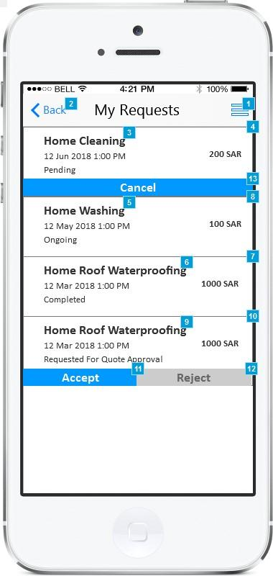

*Figure 16 My Request Screen*

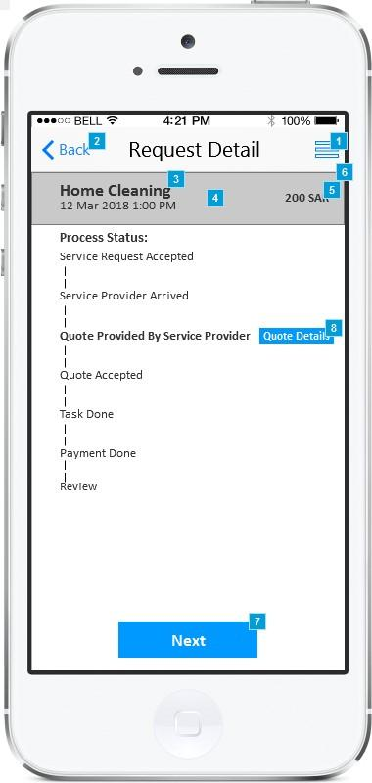

*Figure 17 Request Details Screen 1*

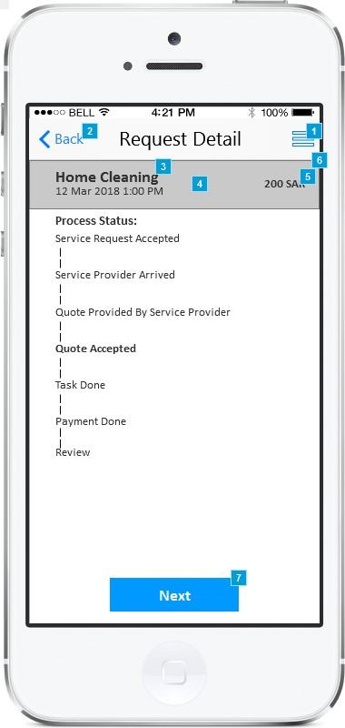

*Figure 18 Request Details Screen 2*

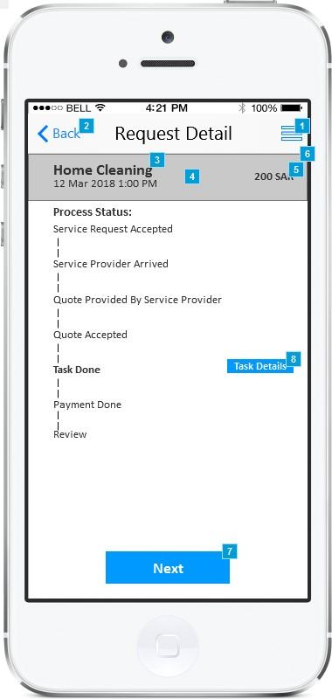

*Figure 19 Request Details Screen 3*

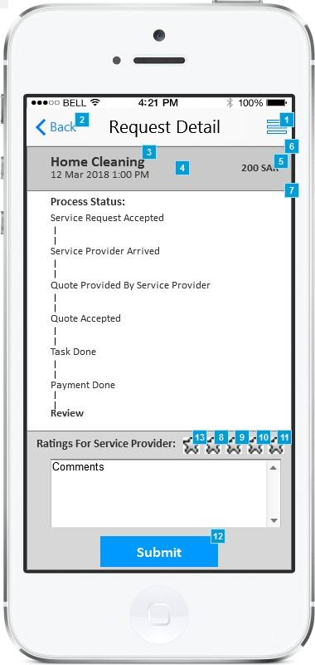

*Figure 20 Request Details Screen 4*

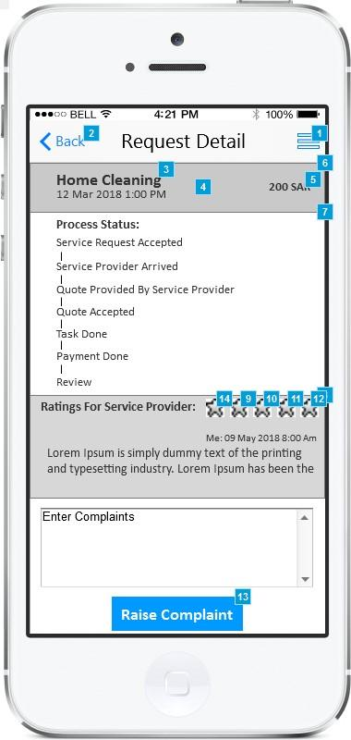

*Figure 21 Request Details Screen 5*

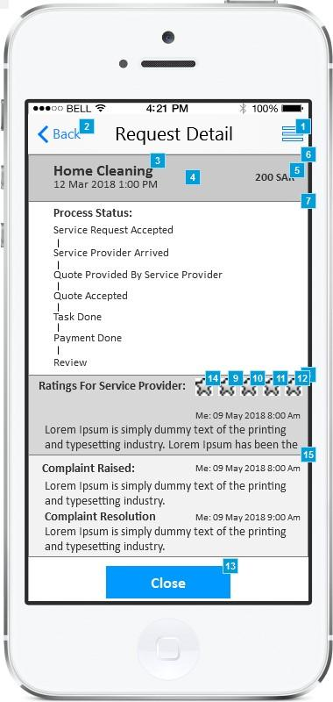

*Figure 22 Request Details Screen 6*

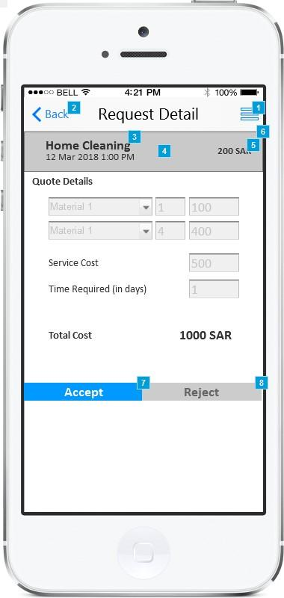

*Figure 23 Quote Details Screen*

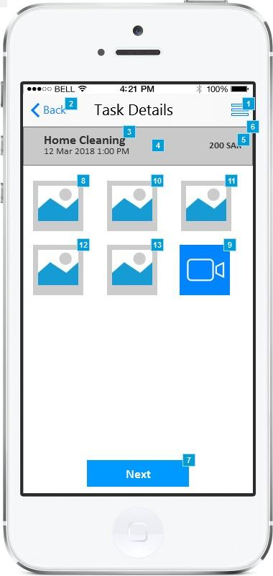

*Figure 24 Task Details Screen*

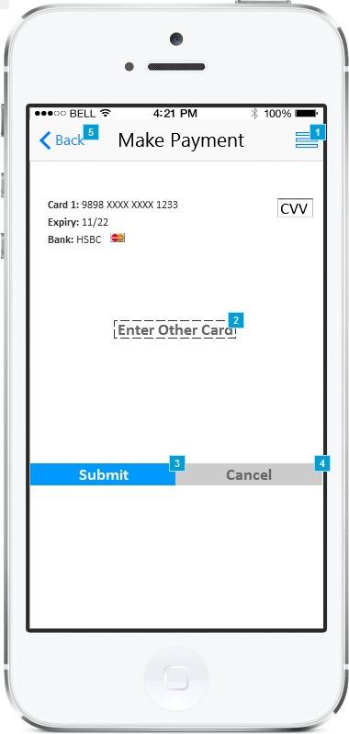

*Figure 25 Payment Details Screen*

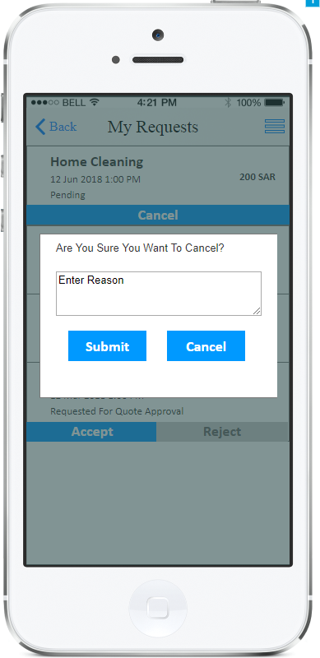

*Figure 26 Cancel/Reject Task*

|  |  |  |
| --- | --- | --- |
| Actor(s) involved | Customer | |
| Requirement definition | Customer will be able to view the service request raised by them and its details. | |
| Pre-condition | Customer is successfully logged into the application and selected “My Request” from the side menu. | |
| Post-condition | Customer will be able to view the details of service request raised by them and take actions according to the status of request. | |
| Business process flow/Business Rules | ***My Request***  Customer will be able to view the list of service request created by them in descending order of date. My request screen will show the list of request which are “new, ongoing as well as created in the past” as shown in figure 16. Each list item will display following details:   1. Service Category 2. Date of Request 3. Amount (It will show the amount proposed by the service provider and accepted by the customer) 4. Status (It will show following status pending/ongoing/completed/requested for quote approval) 5. Action Buttons    1. Accept (It will be used for accepting the quote shared by the service provider)    2. Reject (It will be used to reject the quote provided by service provider. Customer will need to enter the comments if they reject any quote as shown in figure 25).    3. Cancel (It will be used to cancel any ongoing task. Customer can cancel any task until quote is submitted by service provider. Customer will need to enter the comments if they cancel any request as shown in figure 25).   Selecting any service request will navigate the customer to request details screen which is explained in detail below.  ***Request Detail***  Customer will be navigated to the request detail screen by selecting any service request from My Request screen. Request details screen will allow customers to take actions as per the status of the service request. The request detail screen will be divided into following sections:   1. Request Summary    1. Request summary will show details like “Category of service request, Order ID, Date of service request, Cost of Service Request (if quoted by service provider or else it will be blank) and Description”. 2. Request Status    1. Request status section will show the current status of the request. Each status will be made visible as task proceeds. The current status of request will be made bold as shown in figure 17 and will show any action buttons against it. Following is the list of status and action buttons for taking action against it:       1. Service Request Accepted          1. This status will be shown in bold when service request is accepted by the service provider. It will also show the name of service provider.       2. Service Provider Arrived          1. This status will be shown once service provider marks arrived at customer location.       3. Quote Provided by Service Provider          1. This status will be shown in the bold when service provider gives quote to customer and is waiting for customer to accept. This status will show “Quote Details” button as shown in figure 17. Clicking Quote Details button will navigate the customer to quote details screen explained as shown in figure 23.          2. Customer can accept/reject the quote submitted by service provider from “Quote Details” screen or “My Request” screen as shown in figure 16.       4. Quote Accepted          1. This status will be shown in bold once customer accepts the quote by clicking “Accept” button as shown in figure 18.       5. Task Done          1. This status will be show in the bold once the service provider marks the task as done.          2. This status will show “Task Details” button using which the customer will be able to check the photos and videos uploaded by the service provider as shown in figure 19 and 24. Task details screen will give confirmation to customer that task is done properly by service advisor.       6. Payment Done          1. If the customer has selected credit card then amount will be automatically deducted from customer account and “Payment done” status will be made bold. In case the customer has not added any credit card the application will allow them to add credit card as shown in figure 25.          2. If customer has selected cash as mode of payment then this status will be made bold once the service provider marks the payment done.       7. Review          1. After completing the task customer will be able to enter review for service provider by selecting the star rating and entering comments in provided field as shown in figure 20. (1 star is lowest and 5 stars is highest rating).   ***Complaints & Resolution***  Customer will be able to raise complaint against the service received by entering the details in the complaints field as shown in figure 21. The complaints will be sent to the administrator and administrator will be able to give resolution on the complaint. The resolution provided by the admin will be shown below the complaint as shown in figure 22. The resolution will be shown along with timestamp. | |
|  |  | |
|  |  | |
|  | Back | Button |
|  | Side Menu | Button |
|  | Accept | Button |
|  | Reject | Button |
|  | Cancel | Button |
|  | Quote Detail | Button |
|  | Task Detail | Button |
|  | Comment | Text Area |
|  | Complaint | Text Area |
|  | Submit | Button |
|  | Raise Complaint | Button |
|  | Enter Reason | Text Area |

### My Profile Screen

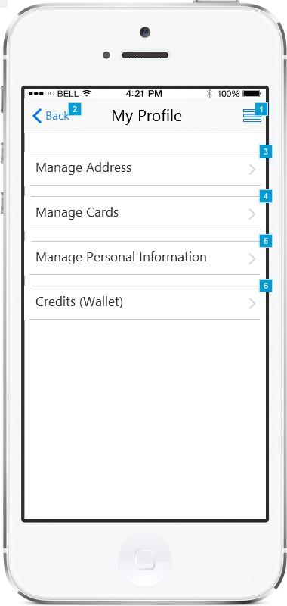

*Figure 27 My Profile Screen*

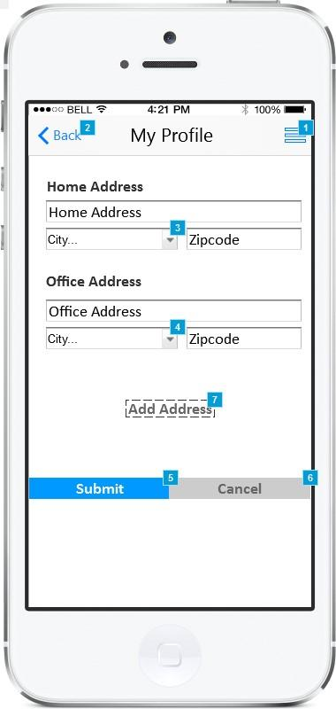

*Figure 28 Manage Address*

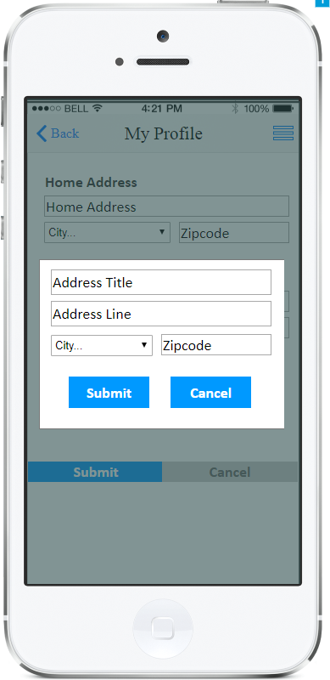

*Figure 29 Add Address*

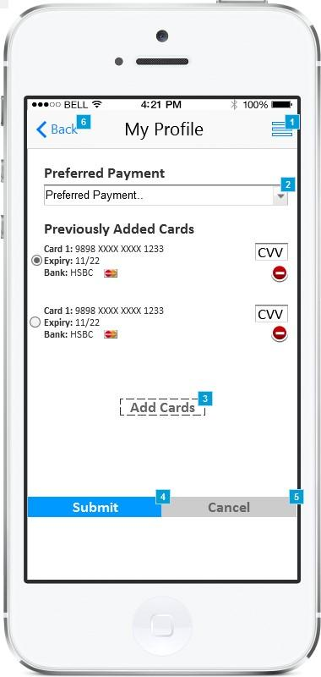

*Figure 30 Manage Cards Screen*

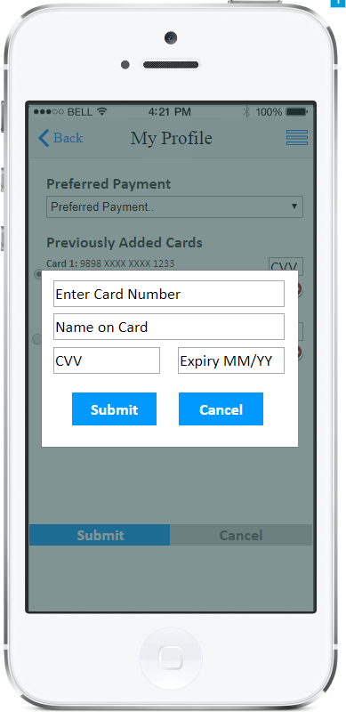

*Figure 31 Add Cards Screen*

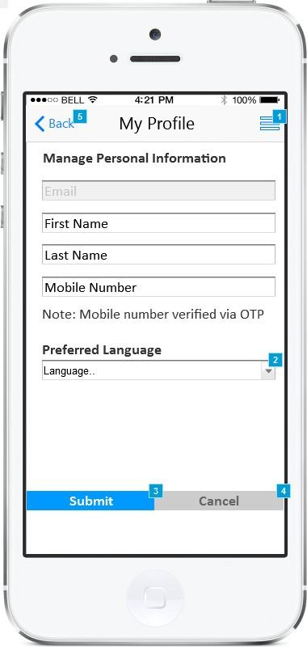

*Figure 32 Manage Personal Information*

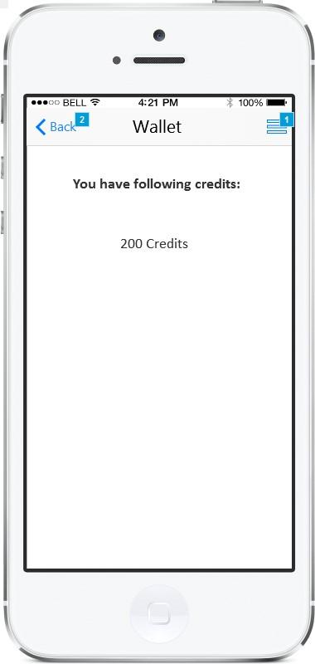

*Figure 33 View Credits Screen*

|  |  |  |
| --- | --- | --- |
| Actor(s) involved | Customer | |
| Requirement definition | Customer will be able to manage their profile details. | |
| Pre-condition | Customer is successfully logged into the application and selected “My Profile” from the side menu. | |
| Post-condition | Customer will be able to view/add/edit/delete the address, cards and personal information. It will also allow customer to view the credits allotted to them. | |
| Business process flow/Business Rules | ***My Profile***  Customer will be able to access sub- screens from my profile screen by clicking the respective menu as shown in figure 27. Customer can access following sub-screens.   1. Manage Address (Clicking this menu will navigate customer to manage address screen which is explained in detail below) 2. Manage Cards (Clicking this menu will navigate customer to manage cards screen which is explained in detail below) 3. Manage Personal Information (Clicking this menu will navigate customer to manage personal information screen which is explained in detail below) 4. Credits (Clicking this menu will navigate customer to view credits screen which is explained in detail below)   ***Mange Address***  Customer will be able to add/edit/delete multiple address as shown in figure 28.  Customer will be able to view the list of existing address added by them. Each list item will show details like “Address Title, Address Line, City and Zip code”.  Customer will be able to add new address by clicking on “Add Address” button and entering following details “Address Title, Address Line, City and Zip code” (as shown in figure 29).  Customer can add maximum 10 address.  ***Mange Cards***  Customer will be able to add/edit/delete multiple credit card as shown in figure 30.  Customer will be able to view the list of existing credit cards added by them. Each list item will show details like “Card Number, Card Name, Expiry Date, Bank Name and Card Provider”.  Customer will be able to add new credit card by clicking on “Add Card” button and entering following details “Card Number, Card Name, Expiry Date, Bank Name and CVV”. Customer will have to accept he auto-debit terms while adding new card so that the service amount can be auto debited from their card.  Customer can make any card default for use by selecting the radio button against the card name.  Customer can also make card or cash as default payment mode by selecting the desired option from dropdown menu. The selected payment mode will be selected by default while creating any new request however customer can change the payment mode manually while creating the request.    ***Mange Personal Information***  Customer will be able to view following personal information “Email, First Name, Last Name, Mobile Number and Preferred Language”.  Customer will be able to edit following information “First Name, Last Name, Mobile Number and Preferred Language”. (Email address cannot be changed as it will be considered as primary key).  Changing the mobile number will require customer to enter OTP into the mobile app which is sent on their mobile number. Entering the OTP will verify the number.  Customer will be able to choose from either English/Arabic as preferred language.    ***Credits***  Customer will be able to view the credits assigned to them by the administrator. Administrator will be able to assign credits to the customer as resolution to any complaint or as per need. These credits will be used by default while paying the cost of service request by customer. Each credit will be equivalent to one SAR.  The credits will be used to pay the cost of service, if any balance amount is left after using credits it will be debited from credit card or by paying cash. | |
|  | **Validation 1 ( Credit Card Validity):**  The credit card information entered by the customer will be verified using the payment gateway API. If the entered information is incorrect or expired following error will be shown to customer “Entered card details are invalid, please enter correct card details”.  **Validation 2 ( OTP Verification):**  The OTP sent to the customer mobile number should match with the value in the database. The OTP will be generated in random order and will be managed in the backend of the application. If the OTP entered by the customer does not match the value in the database then application will show following error “Entered OTP is not correct. Please enter the Correct OTP”.  **Validation 3 (Resend OTP):**  In case the OTP is not received by the customer due to network issues, customer can request another OTP by clicking “Resend OTP” button as shown in figure 4. | |
|  |  | |
|  | Back | Button |
|  | Side Menu | Button |
|  | Cancel | Button |
|  | Submit | Button |
|  | Add Address | Button |
|  | Address Title | Text Field |
|  | Address line | Text Field |
|  | City | Dropdown |
|  | Zip code | Text Field |
|  | First Name | Text Field |
|  | Last Name | Text Field |
|  | Mobile Number | Text Field |
|  | Preferred Language | Dropdown |
|  | Preferred Payment | Dropdown |
|  | Add Cards | Button |
|  | Card Number | Text Field |
|  | Card Name | Text Field |
|  | Expiry Date | Text Field |
|  | CVV | Text Field |

### FAQ Screen

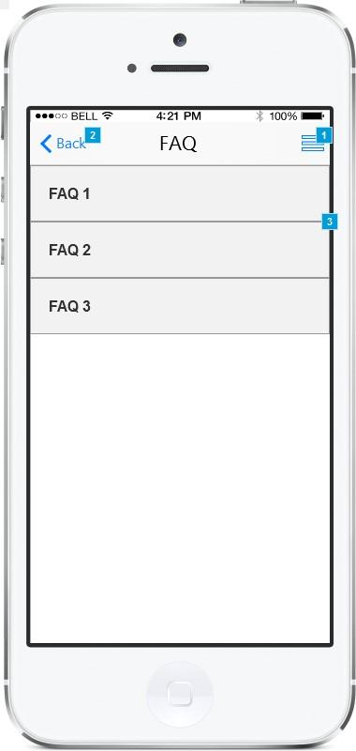

*Figure 34 FAQ Screen*

|  |  |  |
| --- | --- | --- |
| Actor(s) involved | Customer | |
| Requirement definition | Customer will be able to view Frequently Asked Questions. | |
| Pre-condition | Customer is successfully logged into the application and selected “FAQ” from the side menu. | |
| Post-condition | Customer will be able to view Frequently Asked Question and their answers | |
| Business process flow/Business Rules | Customer will be able to view the list of frequently asked question and their answers. FAQ’s will be shown in the form of accordions; clicking any FAQ will expand the accordion to show its answer. FAQ question and their answers will be managed by administrator. FAQ’s will be read only for the customers. | |
|  |  | |
|  |  | |
|  | Back | Button |
|  | Side Menu | Button |

### Contact Us Screen

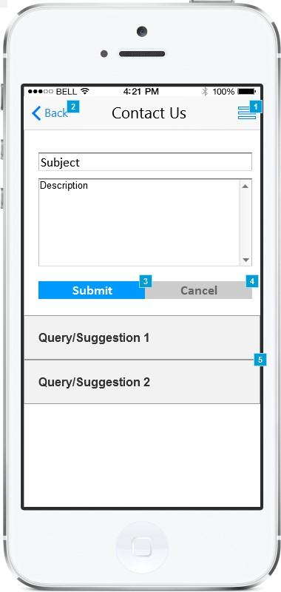

*Figure 35 Contact Us Screen*

|  |  |  |
| --- | --- | --- |
| Actor(s) involved | Customer | |
| Requirement definition | Customer will be able to send suggestion/queries to administrator. | |
| Pre-condition | Customer is successfully logged into the application and selected “Contact Us” from the side menu. | |
| Post-condition | Customer will be able to send queries and suggestions to the administrator. | |
| Business process flow/Business Rules | Customer will be able to send queries/suggestion to the administrator by entering “Subject and Description” in the provided field. Entering the details will send the information to administrator panel. Administrator will be able to reply on the query/suggestion entered by them using the admin panel and the customer will receive the resolution on their query and will be shown as accordion as show in figure 35. | |
|  |  | |
|  |  | |
|  | Back | Button |
|  | Side Menu | Button |
|  | Subject | Text Field |
|  | Description | Text Area |
|  | Submit | Button |
|  | Cancel | Button |

### Refer Friend

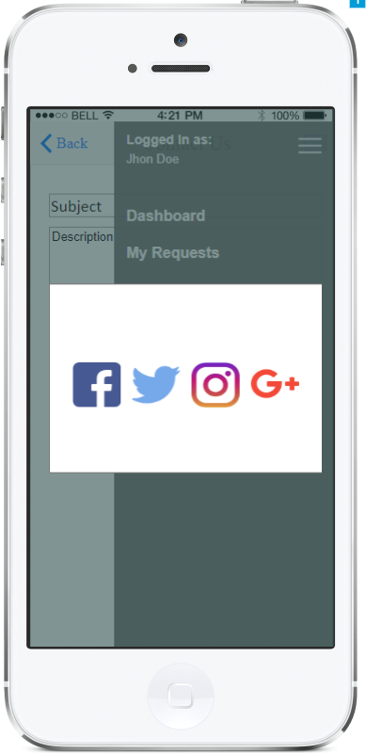

*Figure 36 Share*

|  |  |  |
| --- | --- | --- |
| Actor(s) involved | Customer | |
| Requirement definition | Customer will be able to refer the application to their friends and family. | |
| Pre-condition | Customer is successfully logged into the application and selected “Refer Friend” from the side menu. | |
| Post-condition | Customer will be able to send invite to their friends and family using messaging and social media apps. | |
| Business process flow/Business Rules | Customer will be able to refer application to their friends and family by clicking “Refer Friend” option form side menu and then selecting the social media options like “Facebook, Instagram, Twitter and Google+”. Selecting any social media option will open the respective application on the device with application store link (It will be Apple Store/Play Store link). (Customer should have these social media applications installed on their mobile device). For example, selecting Facebook will open the Facebook app with the application store link auto filled on the post field. | |
|  |  | |
|  |  | |
|  | Back | Button |
|  | Side Menu | Button |

### Notifications

|  |  |  |
| --- | --- | --- |
| Actor(s) involved | Customer | |
| Requirement definition | Customer will receive push notifications for various events which they can view for more details. | |
| Pre-condition | Customer is successfully logged into the application and has application running in the background. | |
| Post-condition | Customer will be able to view various notifications and their details. | |
| Business process flow/Business Rules | Customer will receive push notification on the mobile for following events:   1. Request accepted by service provider    1. Customer will receive push notification if any service provider accepts the request created by them. Selecting the push notification will navigate the customer to the tracking screen explained above. 2. Start Journey, Reach Journey, Cancel journey and No Response    1. Customer will receive push notification for all the status updated mentioned above. These status updates will be entered by service provider. 3. Quote sent by service provider    1. Customer will receive push notification if any service provider sends quote. Selecting the push notification will navigate the customer to the quote details screen explained above. 4. Task done by service provider    1. Customer will receive push notification if any service provider marks the task as complete. Selecting the push notification will navigate the customer to the task details screen explained above. 5. Payment done successfully    1. Customer will receive this push notification in following cases:       1. Card Payment          1. Customer will receive push notification once the amount is auto deducted from the default credit card selected after task is marked complete.       2. Cash Payment          1. In case of cash payment is selected as mode of payment customer will receive push notification once the service provider marks amount as paid from their mobile application. | |
|  |  | |
|  |  | |
|  |  |  |

## Service Provider

### Splash Screen



*Figure 37 Splash Screen*

|  |  |  |
| --- | --- | --- |
| Actor(s) involved | Service Provider | |
| Requirement definition | Service Provider will be able to view the splash screen at the launch of application on their mobile device. | |
| Pre-condition | Service Provider should have the application installed on their device and has launched the application. | |
| Post-condition | Service Provider will be able to view the splash screen for 10 seconds. | |
| Business process flow/Business Rules | Service Provider will be able to view the splash screen for 10 seconds and then they will be redirected to the login screen which is explained in detail below. | |
| Field validation |  | |
|  |  |  |

### Login Screen

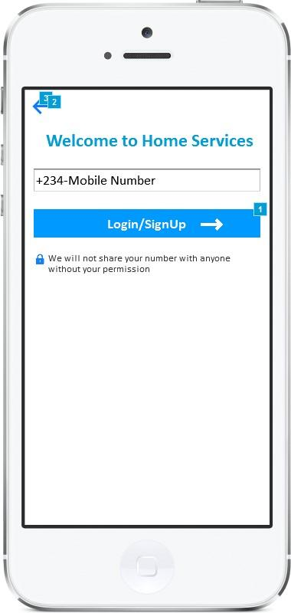

*Figure 38 Login Screen*



*Figure 39 OTP Screen*

|  |  |  |
| --- | --- | --- |
| Actor(s) involved | Service Provider | |
| Requirement definition | Service Provider will be able to login into the application | |
| Pre-condition | Service Provider has launched the application on their mobile device. | |
| Post-condition | Service Provider will be navigated to the dashboard screen. | |
| Business process flow/Business Rules | Service provider will be registered by the administrator of the application. Service provider will receive the login credentials on their email address as soon as the administrator registers them. Login credentials will include details like “Registered phone number, Registered email address, Registered first name and Registered last name”.  Service provider will be able to login using their registered mobile number only.  Service Providers will be able to login by entering their mobile number in the provided field and then clicking “Login” button.  Clicking the login button will send One Time Password (OTP) to service provider mobile number via SMS.  Entering the OTP back into the mobile application will login the service provider into the application. (In case of Android phones the OTP received via SMS will be auto-detected and filled in the OTP field. A standard SMS format will be created for easy detection).  Service provider will need to login only once in the application unless they logout manually. | |
| Field validation | **Validation 1 ( OTP Verification):**  The OTP sent to the service provider mobile number should match with the value in the database. The OTP will be generated in random order and will be managed in the backend of the application. If the OTP entered by the service provider does not match the value in the database then application will show following error “Entered OTP is not correct. Please enter the Correct OTP”.  **Validation 2 (Resend OTP):**  In case the OTP is not received by the service provider due to network issues, service provider can request another OTP by clicking “Resend OTP” button as shown in figure 39. | |
|  |  | |
|  | Mobile Number | Text Field |
|  | OTP | Text Field |
|  | Login | Button |
|  | Resend OTP | Button |

### Dashboard/My Tasks Screen

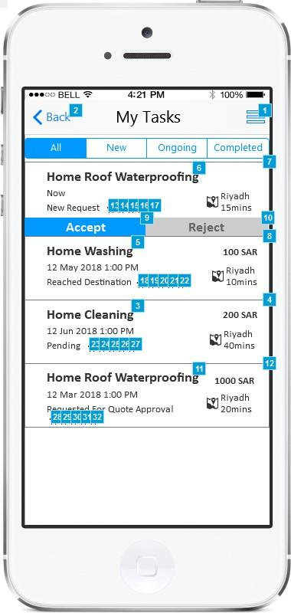

*Figure 40 Dashboard Screen*



*Figure 41 Request Details Screen 1*

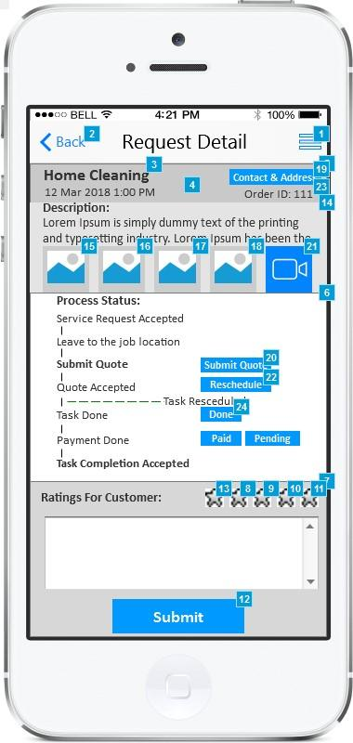

*Figure 42 Request Details Screen 2*

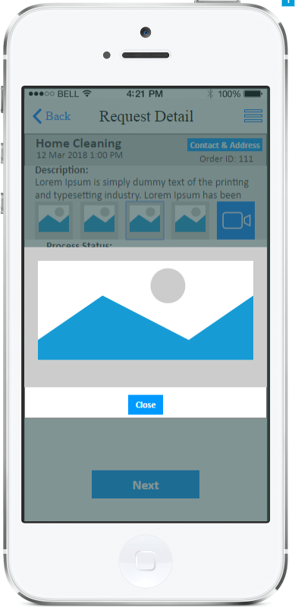

*Figure 43 Media Full Screen*

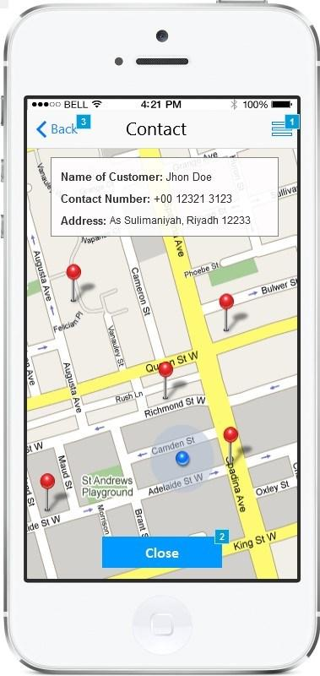

*Figure 44 Contact Screen*

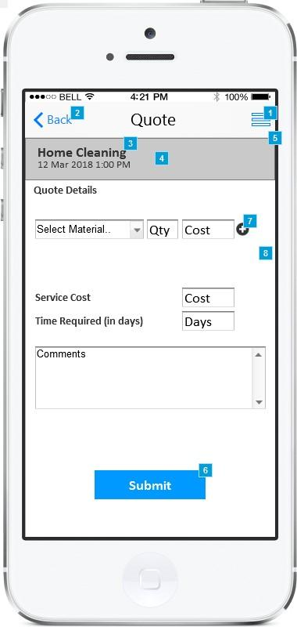

*Figure 45 Submit Quote Screen*

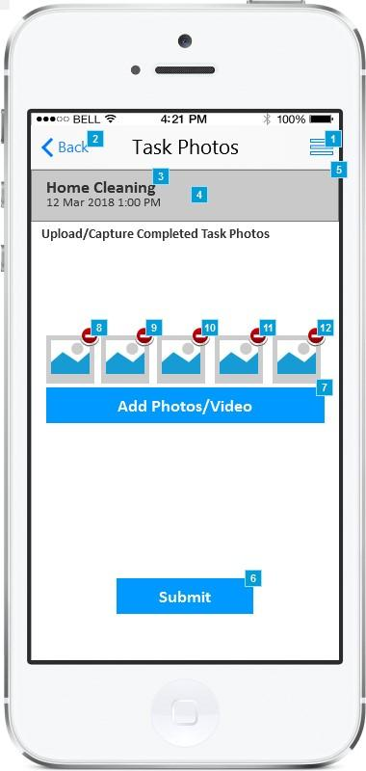

*Figure 46 Task Completed Screen*

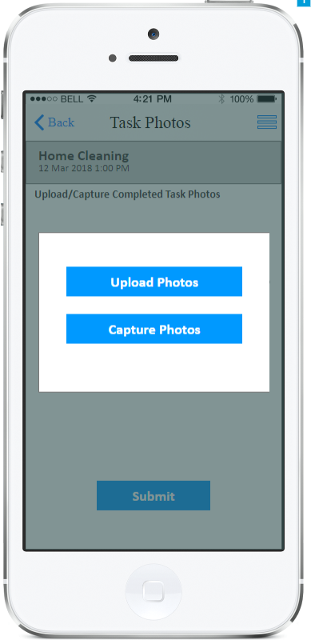

*Figure 47 Upload Photos Screen*

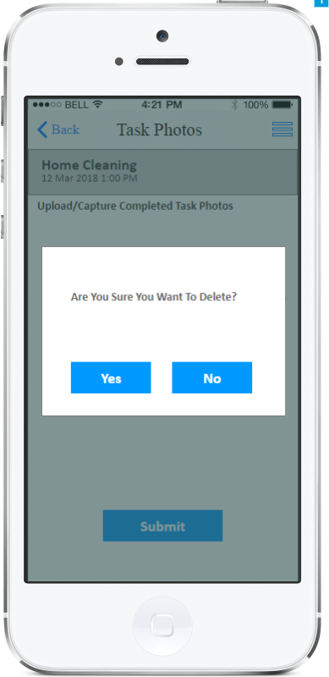

*Figure 48 Delete Photos Screen*

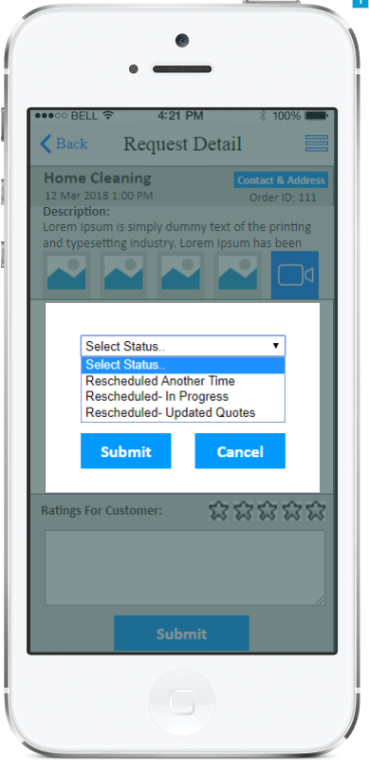

*Figure 49 Reschedule Screen 1*

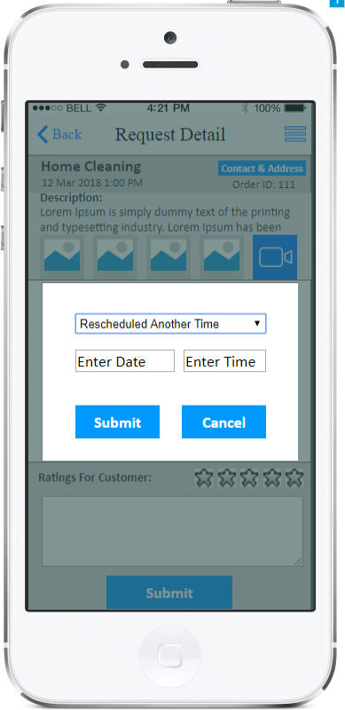

*Figure 50 Reschedule Screen 2*

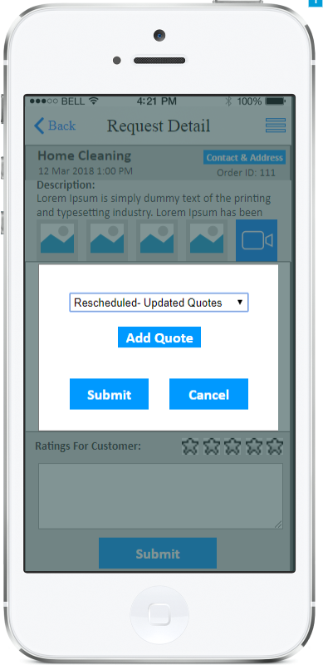

*Figure 51 Reschedule Screen 3*

|  |  |  |
| --- | --- | --- |
| Actor(s) involved | Service Provider | |
| Requirement definition | Service Provider will be able to view the service request raised by customer and its details. | |
| Pre-condition | Service Provider is successfully logged into the application. | |
| Post-condition | Service Provider will be able to view the details of service request raised by customer and take actions according to the status of request. | |
| Business process flow/Business Rules | ***My Tasks***  Service Provider will be able to view the list of service request created by customer in descending order of date. My Tasks screen will show the list of request which are “new, ongoing as well as completed in the past” as shown in figure 40. Each list item will display following details:   1. Service Category 2. Date of Request 3. Amount (It will show the amount proposed by the service provider and accepted by the customer) 4. Status (It will show following status pending/ongoing/completed/requested for quote approval) 5. Action Buttons    1. Accept (It will be used for accepting the service request assigned to them by the application)    2. Reject (It will be used to reject the service request assigned to them by the application. Service Provider will need to enter the comments if they reject any quote as shown in figure 40). 6. Selecting any service request will navigate the service provider to request details screen which is explained in detail below. 7. Service Provider will be able to filter the tasks assigned to them by using the status filter like “All, New, Ongoing, Completed and Cancelled”.   ***Request Detail***  Service Provider will be navigated to the request detail screen by selecting any service request from My Task screen. Request details screen will allow service provider to take actions as per the status of the service request. The request detail screen will be divided into following sections:   1. Request Summary    1. Request summary will show details like “Category of service request, Order ID, Date of service request, Contact Information button, Cost of Service Request (if quoted by service provider or else it will be blank), Description, Customer rating and Media Files (Images/Video)”.    2. Media files will include maximum 5 images and single video of 10 seconds. Service provider will be able to view these media files before accepting/rejecting any offer. Service provider can also view the media files in full screen mode by clicking it as shown in figure 43.    3. Service Provider will be able to view the details of the customer contact information and location by clicking “Contact Information Button”. Clicking this button will navigate the service provider to contact screen as shown in figure 44. Contact screen will show details like “Customer Name, Contact Number, Address and Location on map”. 2. Request/Process Status    1. Request status section will show the current status of the request. Each status will be made visible as task proceeds. The current status of request will be made bold as shown in figure 42 and will show any action buttons against it. Following is the list of status and action buttons for taking action against it:       1. Service Request Accepted          1. This status will be shown in bold when service request is accepted by the service provider. As soon as the service request is accepted by any service provider the request will be shown disabled to other service providers with status as “Assigned to other Service Provider”.       2. Leave for Job Location          1. Once the service request is accepted by the service provider they can take following of actions:             1. Start   Service Provider will be able to start their journey towards the customer location by clicking “Start” button. Clicking “Start” button by service provider will send push notification to customer and also enable the customer to view their live location on the map (It will use the GPS of service provider device)   * + - * 1. Reached   Service Provider will be able to mark as reached to the customer location by clicking “Reached” button. Clicking “Reached” button will send push notification to the customer.   * + - * 1. Cancel   Service Provider will be able to cancel the service request in case of any emergency by clicking cancel button and entering the reason for cancelling.   * + - * 1. No Response   If service provider reaches customer location and doesn’t find any contact person they can mark status as “No Response”. In this case customer will need to raise new request.   * + 1. Submit Quote        1. Once service provider reaches the customer location they can provide quote to the customer after checking the actuals by clicking “Submit Quote” button. Clicking Submit Quote button will navigate service provider to “Submit Quote” page as shown in figure 45.        2. Service provider can enter quote details by entering following details:           1. Material details like “Material Name, Quantity, and Cost”. Service provider can enter multiple material details using the add/remove buttons.           2. Service Cost           3. Number of days required to complete task           4. Comments        3. Entering the quote details will calculate the total sum of all the cost automatically.        4. Service provider will be able to submit the quote to customer by clicking “Submit” button. They can also cancel the quote by clicking “Cancel” button.     2. Quote Accepted        1. This status will be shown in bold once customer accepts the quote by clicking “Accept” button as shown in figure 42. Once quote is accepted by the customer the service provider can start their work.        2. In case of any issues/reasons service provider can reschedule the task after accepting the quote by clicking “Reschedule” button and then selecting the appropriate reason from dropdown menu. They can choose from following reasons:           1. Reschedule Another Time (This option will allow service provider to enter another date and time for performing task as shown in figure 50)           2. Reschedule In Progress (This option will be selected by service provider if they are performing the task on the re-scheduled date as shown in figure 49)           3. Reschedule Update Quotes (This option will allow service provider to re-quote to the customer while rescheduling the task as shown in figure 51. Service Provider will select “Add Quote” button after selecting the option and enter the quote details as explained above. Customer will have to accept the re-quoted amount in order to start the task).     3. Task Done        1. Once the work is done service provider can mark task as done by clicking “Done” button against the “Task done” status. Clicking this button will navigate the service provider to “Task Completed” screen as shown in figure 46.        2. Task completed screen will allow service provider to upload images and video using the mobile application to justify the completed task (As shown in figure 47). They can upload maximum 5 images and one vide of 10 seconds.        3. Uploading the images/video will mark status of task as “Done”. It will send push notification to customer.        4. Service provider can delete the uploaded photos/vide too as shown in figure 48     4. Payment Done        1. Once tasks is done customer will pay the service amount using credit card or cash.        2. If the customer has selected credit card then amount will be automatically deducted from customer account and “Payment done” status will be made bold.        3. If customer has selected cash as mode of payment then this status will be made bold and will enable two buttons i.e. Paid and Pending. Service Provider can click on the “paid” button once they receive cash amount. They can click “pending” button if the cash is pending or task is pending due to some circumstances.     5. Review        1. After completing the task service provider will be able to enter review for customer by selecting the star rating and entering comments in provided field as shown in figure 42. (1 star is lowest and 5 stars is highest rating). | |
|  |  | |
|  |  | |
|  | Back | Button |
|  | Side Menu | Button |
|  | Accept | Button |
|  | Reject | Button |
|  | Cancel | Button |
|  | Start | Button |
|  | Reached | Button |
|  | Cancel | Button |
|  | No Response | Button |
|  | Submit Quote | Button |
|  | Reschedule | Button |
|  | Done | Button |
|  | Paid | Button |
|  | Pending | Button |
|  | Comment | Text Area |
|  | Contact & Address | Button |
|  | Material | Dropdown |
|  | Quantity | Text Field |
|  | Cost | Text Field |
|  | Service Cost | Text Field |
|  | Time Required | Text Field |
|  | Add Photos/Video | Button |
|  | Yes | Button |
|  | No | Button |

### My Profile Screen

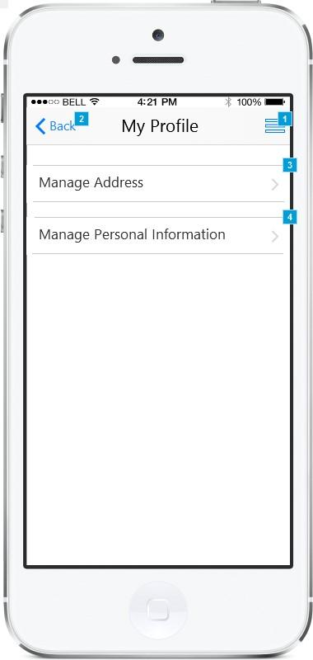

*Figure 52 My Profile Screen*

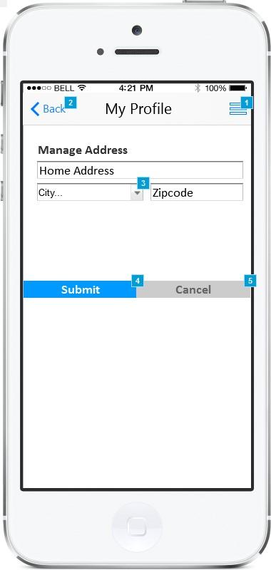

*Figure 53 Manage Address Screen*

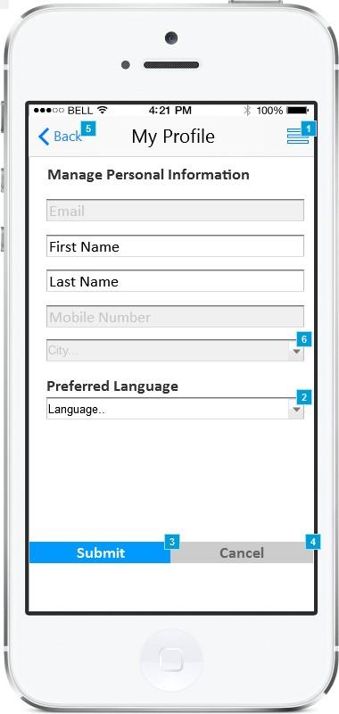

*Figure 54 Manage Personal Information*

|  |  |  |
| --- | --- | --- |
| Actor(s) involved | Service Provider | |
| Requirement definition | Service Provider will be able to manage their profile details. | |
| Pre-condition | Service Provider is successfully logged into the application and selected “My Profile” from the side menu. | |
| Post-condition | Service Provider will be able to view/add/edit/delete the address and their personal information. | |
| Business process flow/Business Rules | ***My Profile***  Service Provider will be able to access sub- screens from my profile screen by clicking the respective menu as shown in figure 52. Customer can access following sub-screens.   1. Manage Address (Clicking this menu will navigate service provider to manage address screen which is explained in detail below) 2. Manage Personal Information (Clicking this menu will navigate service provider to manage personal information screen which is explained in detail below)   ***Mange Address***  Service Provider will be able to edit their own address as shown in figure 53.  Service Provider will be able to add/edit their address by entering details “Address Line, City and Zip code” (as shown in figure 50).  ***Mange Personal Information***  Service provider will be able to view following personal information “Email, First Name, Last Name, Mobile Number, City and Preferred Language”.  Service Provider will be able to edit following information “First Name, Last and Preferred Language”. (Email address, Mobile Number and City cannot be changed as it will manage by administrator).  Service Provider will be able to choose from either English/Arabic as preferred language. | |
|  |  | |
|  |  | |
|  | Back | Button |
|  | Side Menu | Button |
|  | Cancel | Button |
|  | Submit | Button |
|  | Address line | Text Field |
|  | City | Dropdown |
|  | Zip code | Text Field |
|  | First Name | Text Field |
|  | Last Name | Text Field |
|  | Preferred Language | Dropdown |

### Statistics Screen

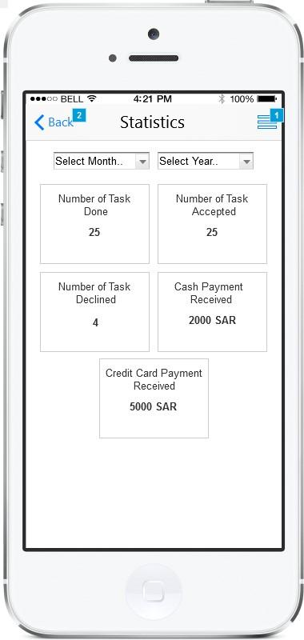

*Figure 55 Statistics Screen*

|  |  |  |
| --- | --- | --- |
| Actor(s) involved | Service Provider | |
| Requirement definition | Service Provider will be able to view their own statistics. | |
| Pre-condition | Service Provider is successfully logged into the application and selected “Statistics” from the side menu. | |
| Post-condition | Service Provider will be able to view their own statistics for any month selected. | |
| Business process flow/Business Rules | Service Provider will be able to view the statistics like “Number of Task Completed, Number of Task Accepted, Number of Task Rejected/Declined, Total Cash Payment received and Credit Card Payment received” by selecting the month and year using the input fields. | |
|  |  | |
|  |  | |
|  | Back | Button |
|  | Side Menu | Button |
|  | Month | Dropdown |
|  | Year | Dropdown |

### FAQ Screen



*Figure 56 FAQ Screen*

|  |  |  |
| --- | --- | --- |
| Actor(s) involved | Service Provider | |
| Requirement definition | Service Provider will be able to view Frequently Asked Questions. | |
| Pre-condition | Service Provider is successfully logged into the application and selected “FAQ” from the side menu. | |
| Post-condition | Service Provider will be able to view Frequently Asked Question and their answers | |
| Business process flow/Business Rules | Service Provider will be able to view the list of frequently asked question and their answers. FAQ’s will be shown in the form of accordions; clicking any FAQ will expand the accordion to show its answer. FAQ question and their answers will be managed by administrator. FAQ’s will be read only for the service provider. | |
|  |  | |
|  |  | |
|  | Back | Button |
|  | Side Menu | Button |

### Contact Us Screen

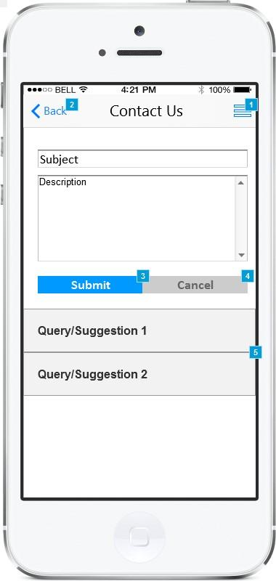

*Figure 57 Contact Us Screen*

|  |  |  |
| --- | --- | --- |
| Actor(s) involved | Service Provider | |
| Requirement definition | Service Provider will be able to send suggestion/queries to administrator. | |
| Pre-condition | Service Provider is successfully logged into the application and selected “Contact Us” from the side menu. | |
| Post-condition | Service Provider will be able to send queries and suggestions to the administrator. | |
| Business process flow/Business Rules | Service Provider will be able to send queries/suggestion to the administrator by entering “Subject and Description” in the provided field. Entering the details will send the information to administrator panel. Administrator will be able to reply on the query/suggestion entered by them using the admin panel and the service provider will receive the resolution on their query and will be shown as accordion as show in figure 57. | |
|  |  | |
|  |  | |
|  | Back | Button |
|  | Side Menu | Button |
|  | Subject | Text Field |
|  | Description | Text Area |
|  | Submit | Button |
|  | Cancel | Button |

### Refer Friend



*Figure 58 Share*

|  |  |  |
| --- | --- | --- |
| Actor(s) involved | Service Provider | |
| Requirement definition | Service Provider will be able to refer the application to their friends and family. | |
| Pre-condition | Service Provider is successfully logged into the application and selected “Refer Friend” from the side menu. | |
| Post-condition | Service Provider will be able to send invite to their friends and family using messaging and social media apps. | |
| Business process flow/Business Rules | Service Provider will be able to refer application to their friends and family by clicking “Refer Friend” option form side menu and then selecting the social media options like “Facebook, Instagram, Twitter and Google+”. Selecting any social media option will open the respective application on the device with application store link (It will be Apple Store/Play Store link). (Customer should have these social media applications installed on their mobile device). For example, selecting Facebook will open the Facebook app with the application store link auto filled on the post field. | |
|  |  | |
|  |  | |
|  | Back | Button |
|  | Side Menu | Button |

### Notifications

|  |  |  |
| --- | --- | --- |
| Actor(s) involved | Service Provider | |
| Requirement definition | Service Provider will receive push notifications for various events which they can view for more details. | |
| Pre-condition | Service Provider is successfully logged into the application has application running in the background. | |
| Post-condition | Service Provider will be able to view various notifications and their details. | |
| Business process flow/Business Rules | Service Provider will receive push notification on the mobile for following events:   1. Request created by customer    1. Service Provider will receive push notification if any customer creates service request and the service provider is within 10km radius. Clicking the notification will navigate the service provider to the request details screen which is explained above. 2. Quote accepted by customer    1. Service Provider will receive push notification if customer accepts the quote sent by them. Selecting the push notification will navigate the service provider to request details screen explained above. 3. Payment done successfully    1. Service Provider will receive this push notification after successful payment by customer in case the customer has selected credit card as payment mode. (The amount will be auto deducted from the card and notification will be sent to both service provider and customer). | |
|  |  | |
|  |  | |
|  |  |  |
|  |  |  |

## Administrator

### Login

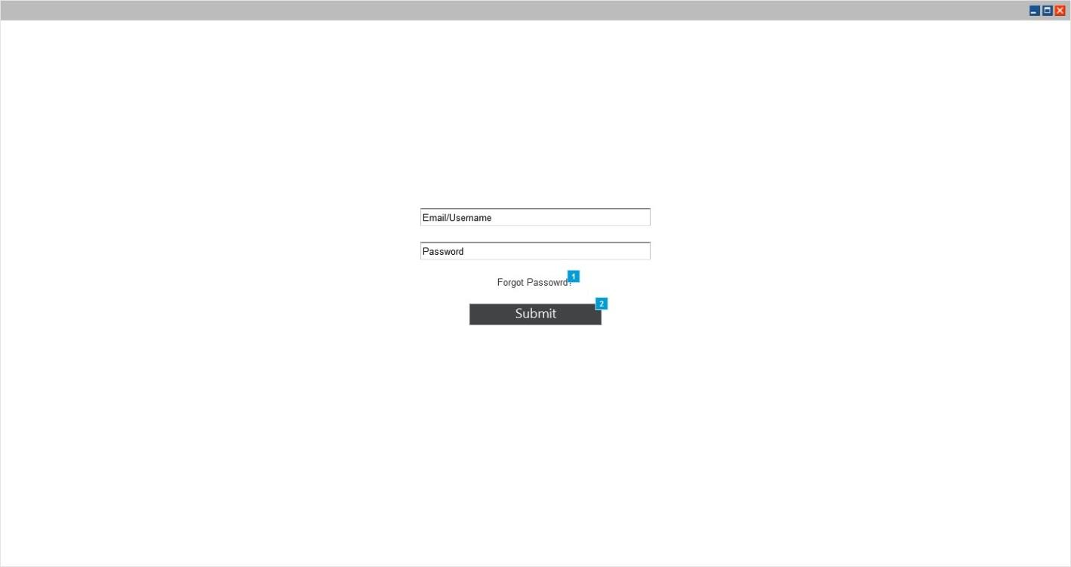

*Figure 59 Login*

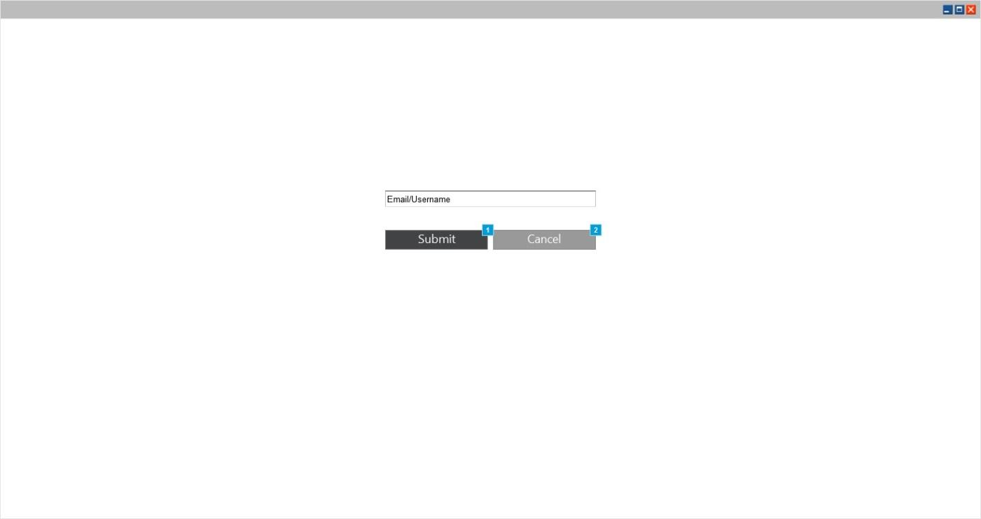

*Figure 60 Forgot Password*

|  |  |  |
| --- | --- | --- |
| Actor(s) involved | Administrator | |
| Requirement definition | Administrator will be able to login using their registered email address and password. | |
| Pre-condition | Administrator has entered correct URL in the browser. | |
| Post-condition | Administrator will be navigated to the dashboard | |
| Business process flow/Business Rules | Administrator will be able to login in to the application by entering the registered email address and password.  Administrator will be able to reset their password by clicking “Forgot Password” link and then entering registered email address.  Entering the email address will send password reset link to the email. Clicking the password reset will navigate admin to web page where they can enter their new password. | |
| Field validation |  | |
|  | Email | Text Field |
|  | Password | Text Field |
|  | Login | Button |
|  | Submit | Button |
|  | Cancel | Button |

### Dashboard

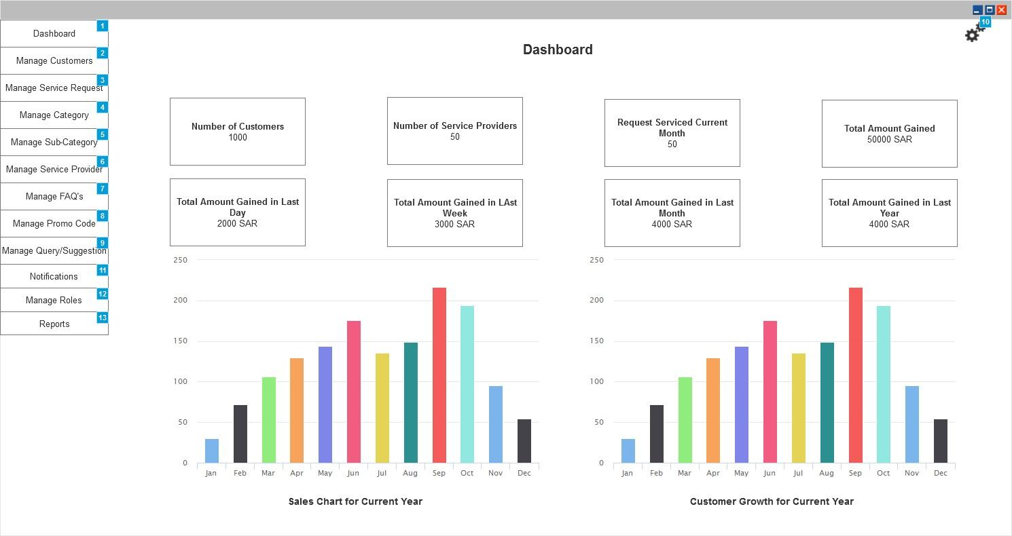

*Figure 61 Dashboard*

|  |  |  |
| --- | --- | --- |
| Actor(s) involved | Administrator | |
| Requirement definition | Administrator will be able to view the dashboard and its details | |
| Pre-condition | Administrator has successfully logged into the application | |
| Post-condition | Administrator will be able to view details on the dashboard and navigate to other pages of the admin panel using the menu. | |
| Business process flow/Business Rules | Administrator will be able get overview of entire application and its transactions using the dashboard.  Administrator will be able to view information in 2 sections which are as follows:   * 1. Coasters Section      1. This section will show coasters which will allow admin to get glimpse of transactions within the application. Following coasters will be shown:         1. Number of Customers Registered         2. Number of Service Providers         3. Number of service request created by customers this month         4. Total revenue generated till date from the start of application         5. Revenue generated in last day         6. Revenue generated in last week (Calendar week)         7. Revenue generated in last month (Calendar month)         8. Revenue generated in last year   2. Charts Section      1. This section will allow the customers to view the growth rate of sales/revenue and customers.      2. First chart will be shown with revenue/sales on y-axis and months on x-axis.      3. Second chart will be shown with number of customers on y-axis and months on x-axis | |
| Field validation |  | |
|  |  |  |
|  |  |  |

### Manage Customers

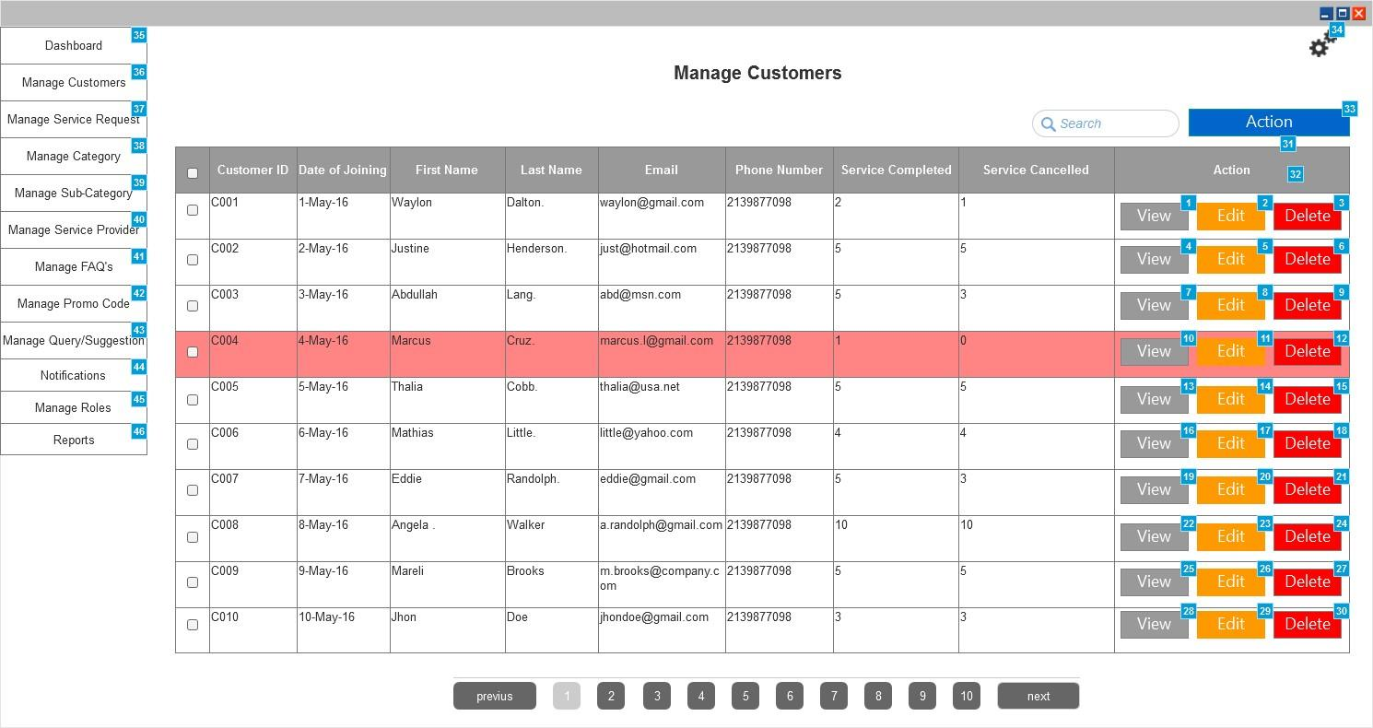

*Figure 62 Manage Customers*

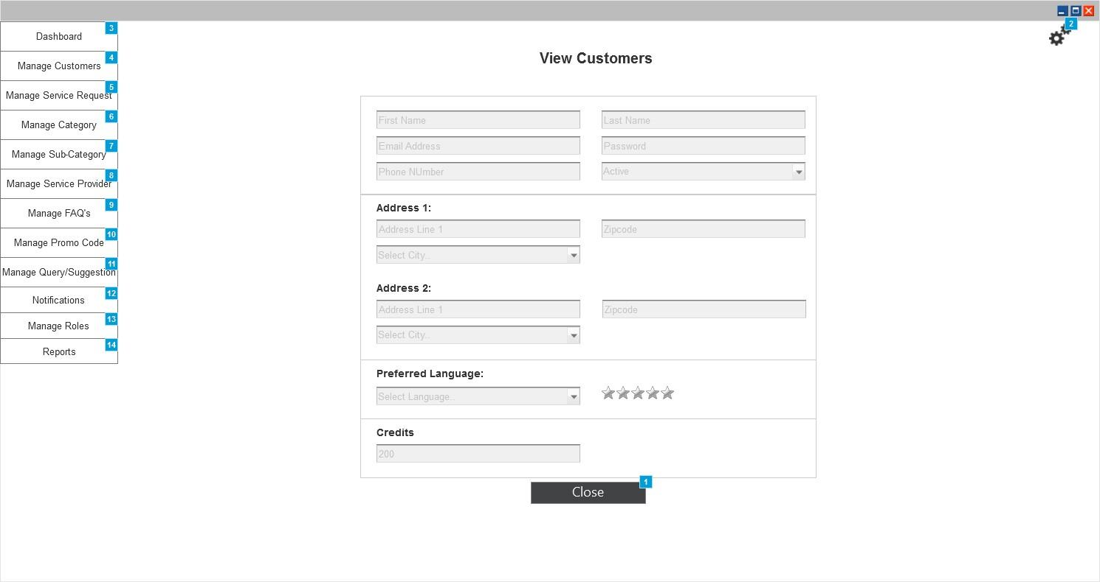

*Figure 63 View Customers*

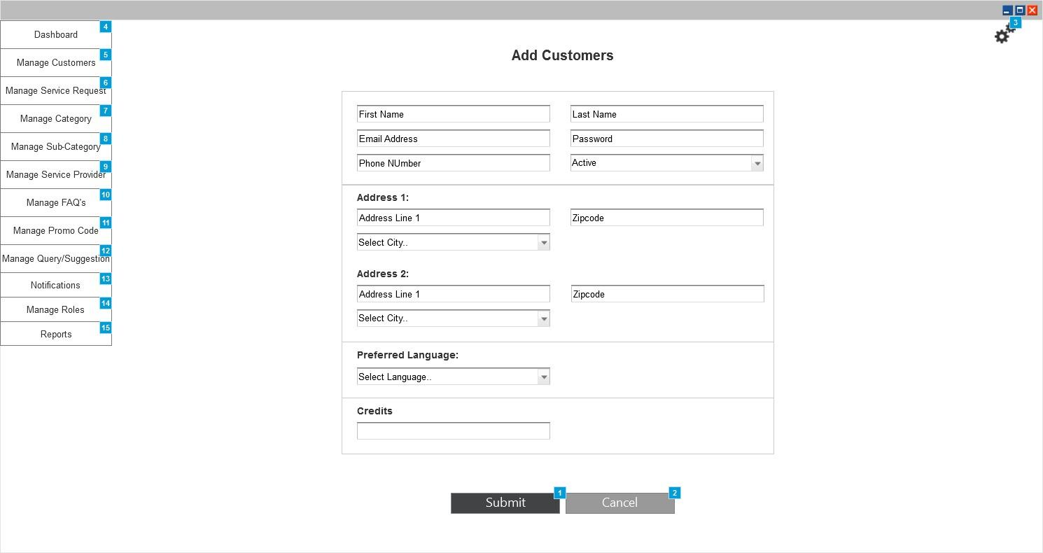

*Figure 64 New Customers*

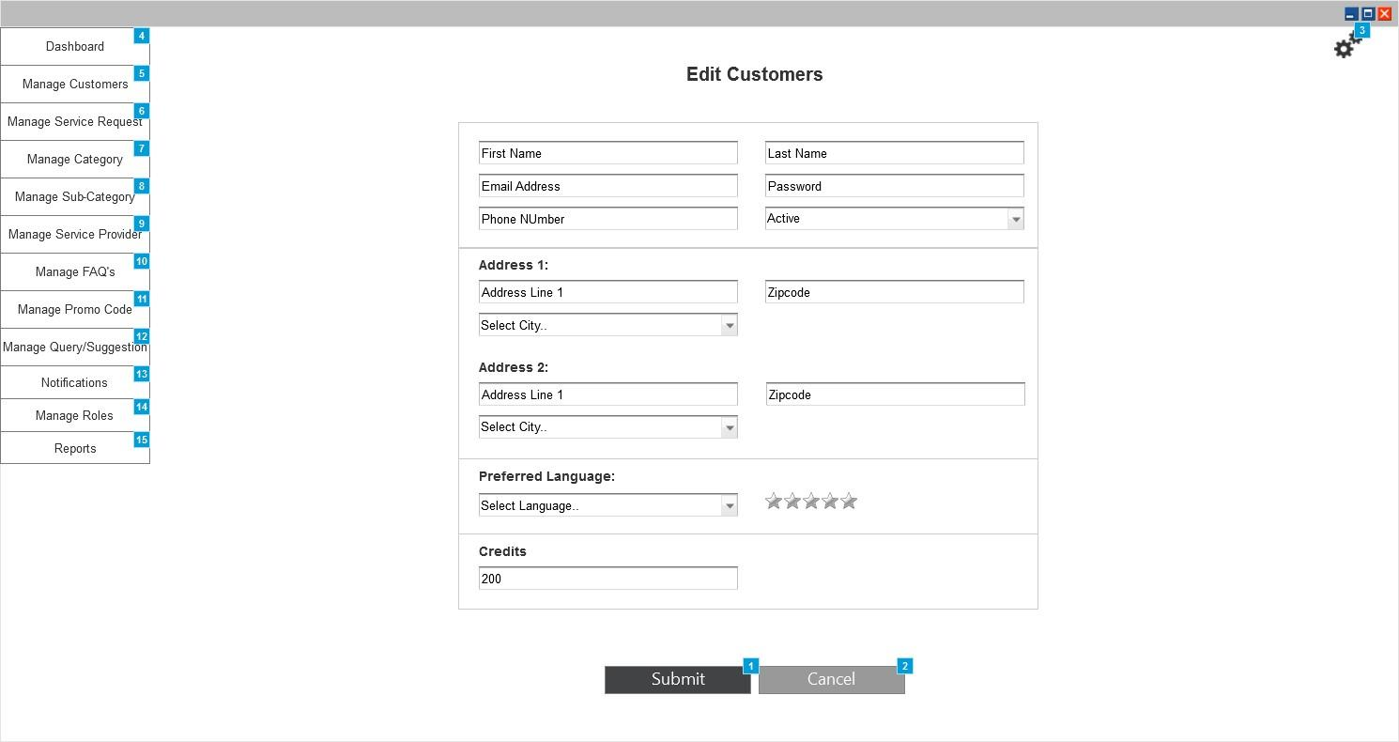

*Figure 65 Edit Customers*

|  |  |  |
| --- | --- | --- |
| Actor(s) involved | Administrator | |
| Requirement definition | Administrator will be able to manage the customers. | |
| Pre-condition | Administrator has successfully logged into application and selected Manage Customers from menu | |
| Post-condition | Administrator will be able to view/add/edit/delete customers from this section | |
| Business process flow/Business Rules | ***Manage Customers***  Administrator will be able to view the list of existing customers in the application (as shown in figure 62). Customers details will be arranged in the form of table where each line item will show following details:   1. Customer ID 2. Date of Joining 3. First Name 4. Last Name 5. Email 6. Phone Number 7. Service Completed 8. Services Cancelled 9. Action Buttons    1. View (Clicking this button will navigate admin to the view page explained below)    2. Edit (Clicking this button will navigate admin to the edit page explained below)    3. Delete (Clicking this button will delete the selected line item after confirmation).   Admin will be able to perform bulk delete actions by enabling checkbox against each item in the table and then clicking “Delete” menu item from the Action menu.  Admin can add new customer manually by clicking “Add” menu item from the Action menu and then entering the details. Clicking “Add” menu will navigate admin to the new customer page explained below.  Any customer made inactive will be shown with red highlight.  ***View Customers***  Admin will be able to view following details of the customer on the view page:   1. First Name 2. Last Name 3. Email 4. Phone Number 5. Status (Active/Inactive) 6. Average Rating (given by service providers) 7. Multiple Addresses added by them which will include “Address line, City and Zip code”. 8. Preferred Language 9. Credits in balance 10. History of changes done. Each history item will display the details like “Name of User, Date of changes done, Time of Changes done and Changed Value”.   ***Add Customers***  Admin will be able to add new customer manually by entering following details:   1. First Name 2. Last Name 3. Email 4. Phone Number 5. Password 6. Status (Active/Inactive) 7. Multiple addresses them which will include “Address line, City and Zip code”. 8. Preferred Language 9. Credits in balance   ***Edit Customers***  Admin will be able to edit following details of the customers:   1. First Name 2. Last Name 3. Email 4. Phone Number 5. Status (Active/Inactive) 6. Password 7. Average Rating (given by service providers) 8. Multiple Addresses added by them which will include “Address line, City and Zip code”. 9. Preferred Language 10. Credits in balance | |
| Field validation |  | |
|  | First Name | Text Field |
|  | Last Name | Text Field |
|  | Email | Text Field |
|  | Phone Number | Text Field |
|  | Password | Text Field |
|  | Status | Dropdown |
|  | Address Line | Text Field |
|  | City | Dropdown |
|  | Zip code | Text Field |
|  | Preferred Language | Dropdown |
|  | Credits | Text Field |
|  | Action | Menu |
|  | View | Button |
|  | Edit | Button |
|  | Delete | Button |
|  | Submit | Button |
|  | Cancel | Button |

### Manage user

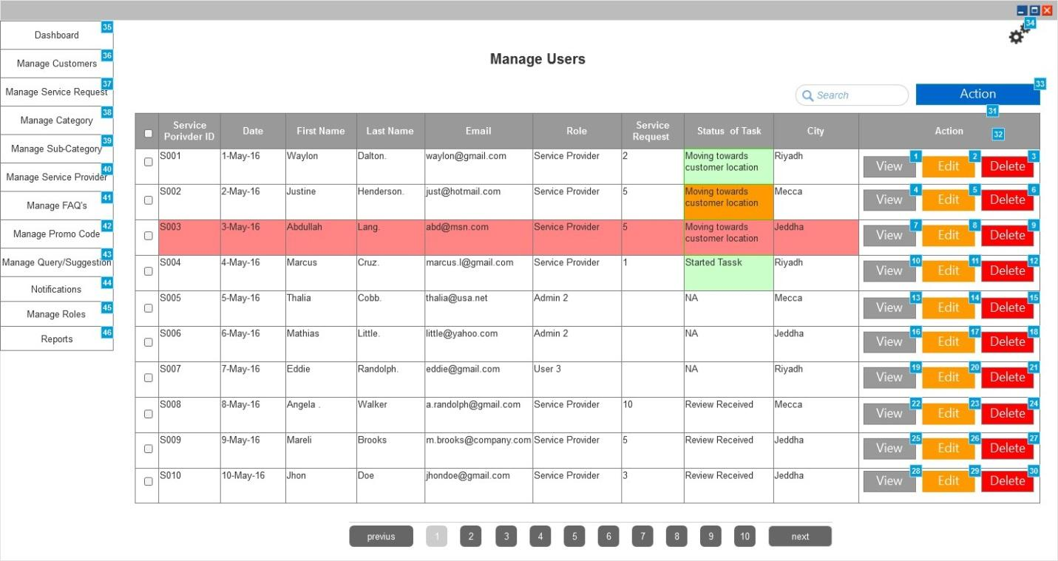

*Figure 66 Manage Service Provider*

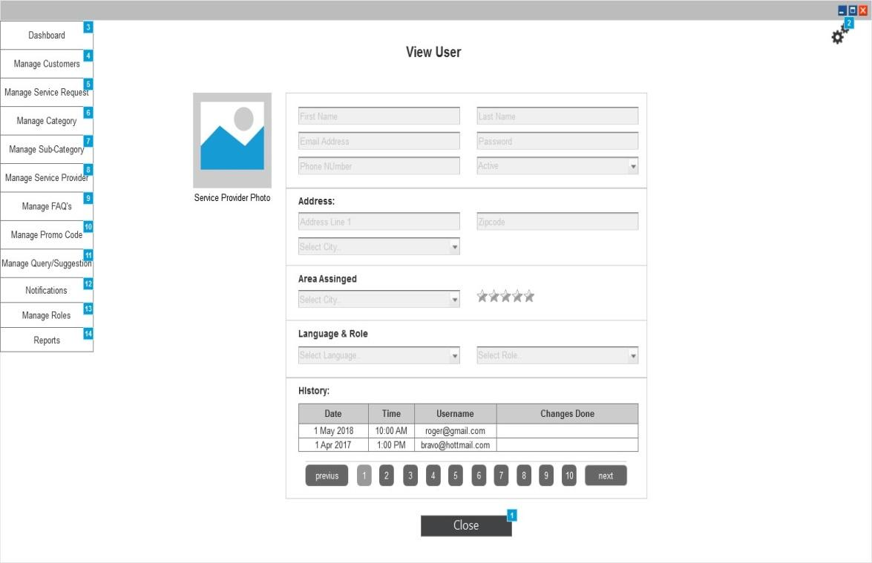

*Figure 67 View Service Provider*

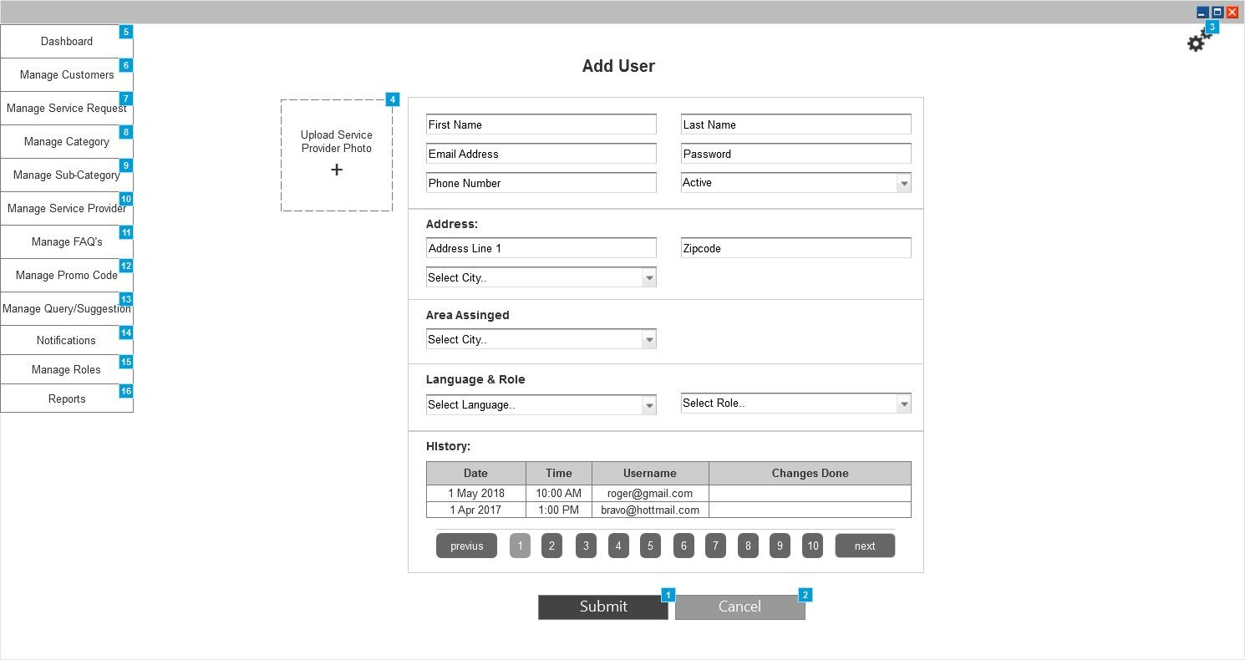

*Figure 68 New Service Provider*

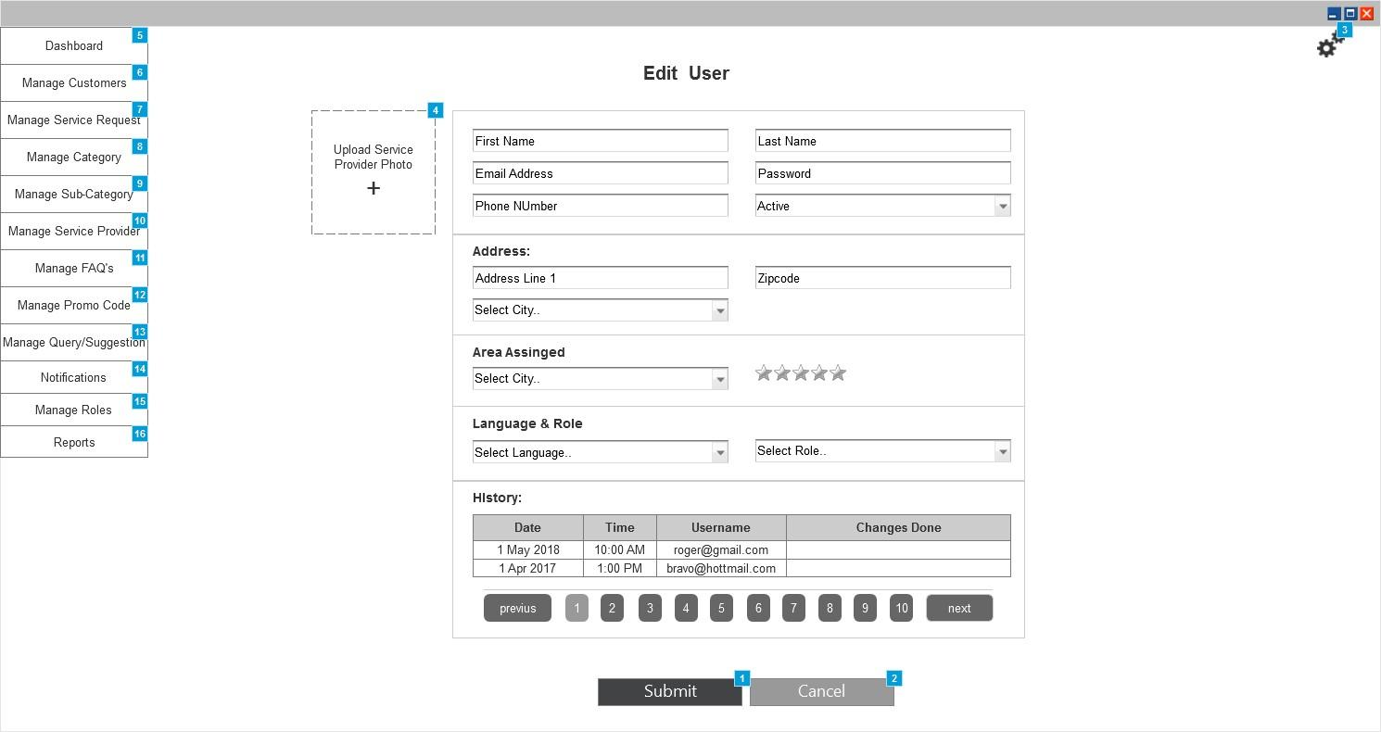

*Figure 69 Edit Service Provider*

|  |  |  |
| --- | --- | --- |
| Actor(s) involved | Administrator | |
| Requirement definition | Administrator will be able to manage the users | |
| Pre-condition | Administrator has successfully logged into application and selected Manage Users from menu | |
| Post-condition | Administrator will be able to view/add/edit/delete users from this section | |
| Business process flow/Business Rules | ***Manage Users***  Administrator will be able to view the list of existing service providers in the application (as shown in figure 66). Service Provider details will be arranged in the form of table where each line item will show following details:   1. Service Provider ID 2. Date of Joining 3. First Name 4. Last Name 5. Email 6. Phone Number 7. Service request completed till date 8. Status of Task    1. This column will show the “Status of task and Time stamp”. Based on the time elapsed after updating the status the column will be highlighted will different colors. Color will be shown green if the time elapsed is less than 30 mins after updating the task status, it will be orange if time elapsed is between 30 to 45 mins and red if its more than 45 mins. 9. City 10. Action Buttons     1. View (Clicking this button will navigate admin to the view page explained below)     2. Edit (Clicking this button will navigate admin to the edit page explained below)     3. Delete (Clicking this button will delete the selected line item after confirmation).   Admin will be able to perform bulk delete actions by enabling checkbox against each item in the table and then clicking “Delete” menu item from the Action menu.  Admin can add new service provider manually by clicking “Add” menu item from the Action menu and then entering the details. Clicking “Add” menu will navigate admin to the new service provider page explained below.  Complete row will be highlighted with red color as shown in figure 66 if the user is inactive.  ***View Service provider***  Admin will be able to view following details of the service providers on the view page:   1. First Name 2. Last Name 3. Email 4. Phone Number 5. Status (Active/Inactive) 6. Profile Photo 7. Average Rating (given by customers) 8. Addresses details like “Address line, City and Zip code”. 9. Area Assigned 10. Preferred Language 11. Role 12. History of changes done. Each history item will display the details like “Name of User, Date of changes done, Time of Changes done and Changed Value”.   ***Add Service Provider***  Admin will be able to add new service provider manually by entering following details:   1. First Name 2. Last Name 3. Email 4. Phone Number 5. Password 6. Profile Photo 7. Address details like “Address line, City and Zip code”. 8. Area to be assigned 9. Preferred Language 10. Role   ***Edit Service Provider***  Admin will be able to edit following details of the service provider:   1. First Name 2. Last Name 3. Email 4. Phone Number 5. Password 6. Profile Photo 7. Average Rating (given by service providers) 8. Address details like “Address line, City and Zip code”. 9. Area Assigned 10. Preferred Language 11. Role | |
| Field validation |  | |
|  | First Name | Text Field |
|  | Last Name | Text Field |
|  | Email | Text Field |
|  | Phone Number | Text Field |
|  | Status | Dropdown |
|  | Profile Photos | Upload |
|  | Password | Text Field |
|  | Address Line | Text Field |
|  | City | Dropdown |
|  | Zip code | Text Field |
|  | Preferred Language | Dropdown |
|  | Role | Dropdown |
|  | Area Assigned | Dropdown |
|  | Action | Menu |
|  | View | Button |
|  | Edit | Button |
|  | Delete | Button |
|  | Submit | Button |
|  | Cancel | Button |

### Manage Service Request

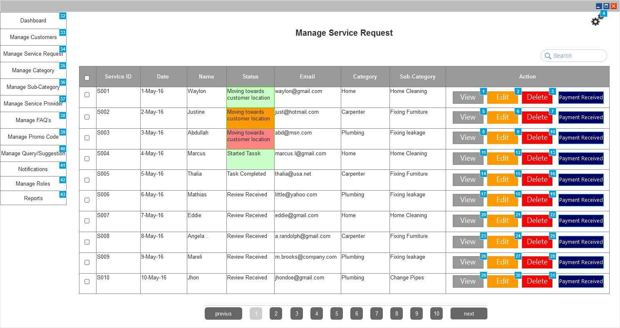

*Figure 70 Manage Service Request*

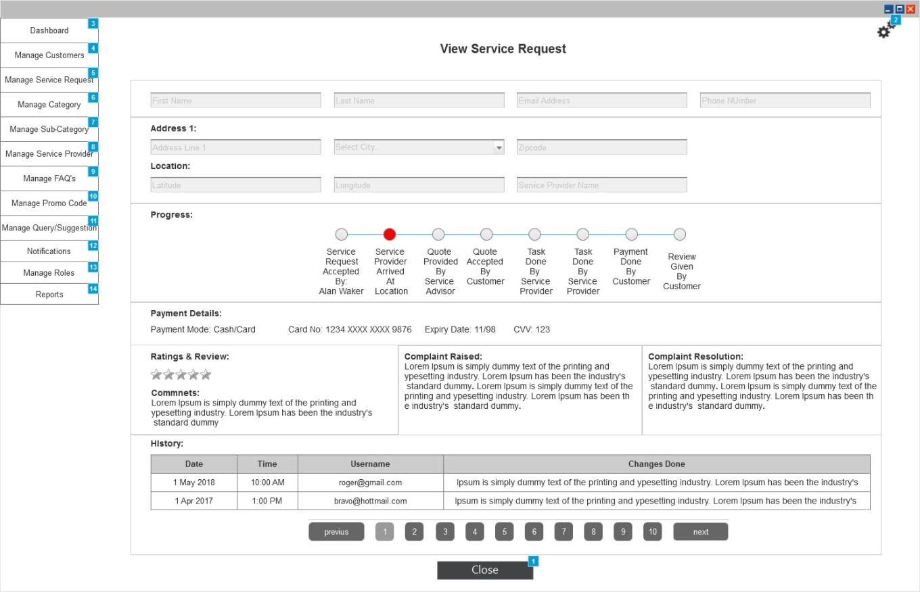

*Figure 71 View Service Request*

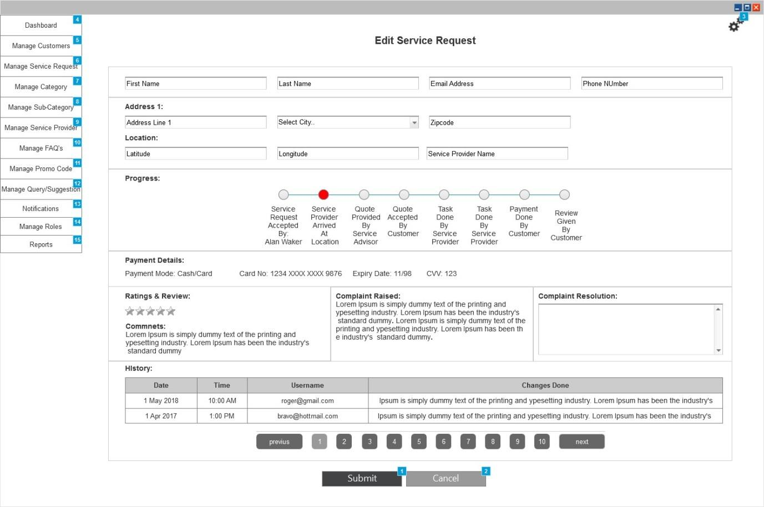

*Figure 72 Edit Service Request*

|  |  |  |
| --- | --- | --- |
| Actor(s) involved | Administrator | |
| Requirement definition | Administrator will be able to manage the service request raised by the customers | |
| Pre-condition | Administrator has successfully logged into application and selected Manage Service Requests from menu | |
| Post-condition | Administrator will be able to view/edit/delete service requests from this section | |
| Business process flow/Business Rules | ***Manage Service Request***  Administrator will be able to view the list of existing service requests in the application (as shown in figure 70). Service Request details will be arranged in the form of table where each line item will show following details:   1. Service Request/Order ID 2. Date 3. Name 4. Status of Task    1. This column will show the “Status of task and Time stamp”. Based on the time elapsed after updating the status the column will be highlighted will different colors. Color will be shown green if the time elapsed is less than 30 mins after updating the task status, it will be orange if time elapsed is between 30 to 45 mins and red if its more than 45 mins. 5. Email 6. Category 7. Sub-Category 8. Action Buttons    1. View (Clicking this button will navigate admin to the view page explained below)    2. Edit (Clicking this button will navigate admin to the edit page explained below)    3. Delete (Clicking this button will delete the selected line item after confirmation).    4. Payment (Clicking this button will confirm that payment has been received by accountant or any responsible person from the service provider. Admin or accountant will be able to enter the amount received from service provider and view the pending amount.)   Admin will be able to perform bulk delete actions by enabling checkbox against each item in the table and then clicking “Delete” menu item from the Action menu.  ***View Service request***  Admin will be able to view following details of the service request on the view page:   1. First Name 2. Last Name 3. Email 4. Phone Number 5. Address & Location details (It will show details like “Address line, City, Zip Code, Latitude and Longitude) 6. Service Provider name 7. Progress (It will show the status of service request in the form of progress bar as shown in figure 71. It will display the status updated/marked by both customer and service provider) 8. Payment Details    1. It will show details like “Payment mode i.e. card/cash, Amount and Card details (Card details will include Card number, Card name, Expiry date and CVV). 9. Rating and Comment (given by customers) 10. Complaint details 11. Complaint resolution provided by admin 12. History of changes done. Each history item will display the details like “Name of User, Date of changes done, Time of Changes done and Changed Value”.   ***Edit Service Provider***  Admin will be able to edit following details of the service request:   1. First Name 2. Last Name 3. Email 4. Phone Number 5. Address & Location details like “Address line, City, Zip Code, Latitude and Longitude. 6. Complaint resolution (Admin can enter their resolution details if against any complaint raised by customer). 7. History of changes done. Each history item will display the details like “Name of User, Date of changes done, Time of Changes done and Changed Value”. | |
| Field validation |  | |
|  | First Name | Text Field |
|  | Last Name | Text Field |
|  | Email | Text Field |
|  | Phone Number | Text Field |
|  | Address Line | Text Field |
|  | City | Dropdown |
|  | Zip code | Text Field |
|  | Latitude | Text Field |
|  | Longitude | Text Field |
|  | Complaint resolution | Text Area |
|  | View | Button |
|  | Edit | Button |
|  | Delete | Button |
|  | Submit | Button |
|  | Cancel | Button |

### Manage Category

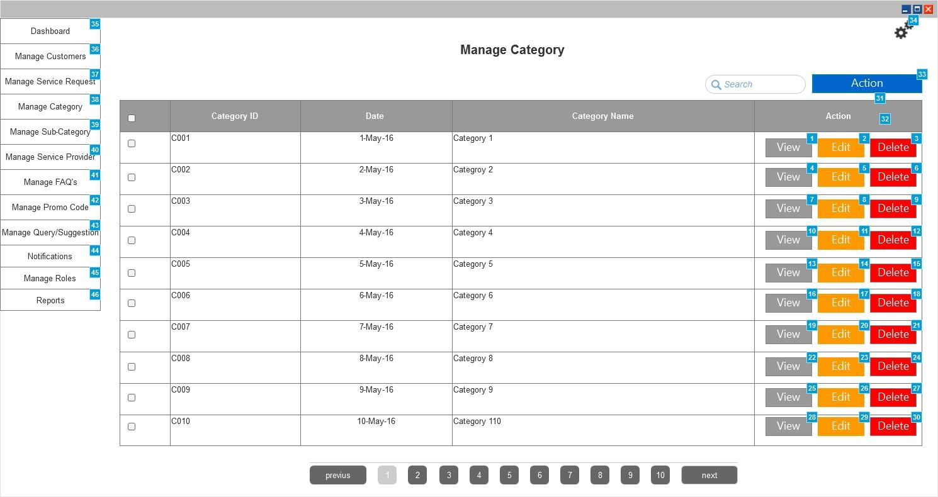

*Figure 73 Manage Category*

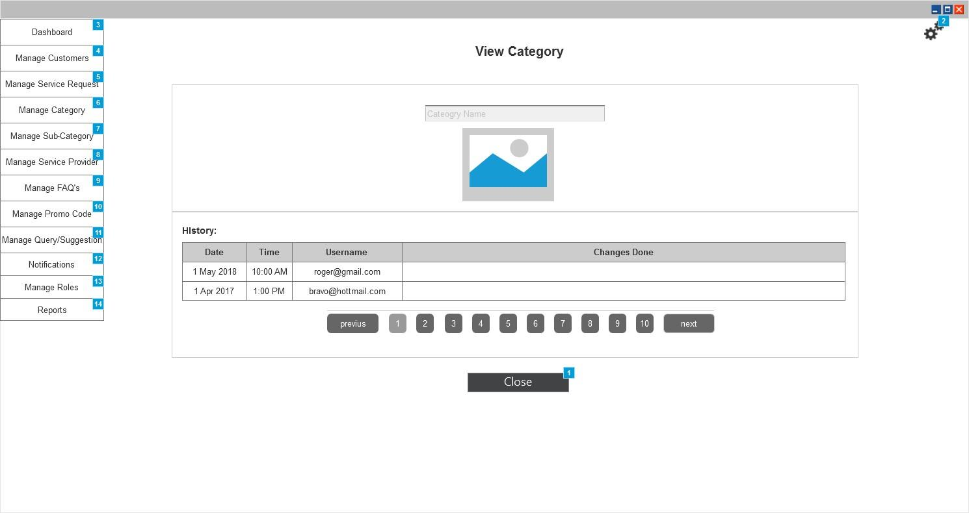

*Figure 74 View Service Provider*

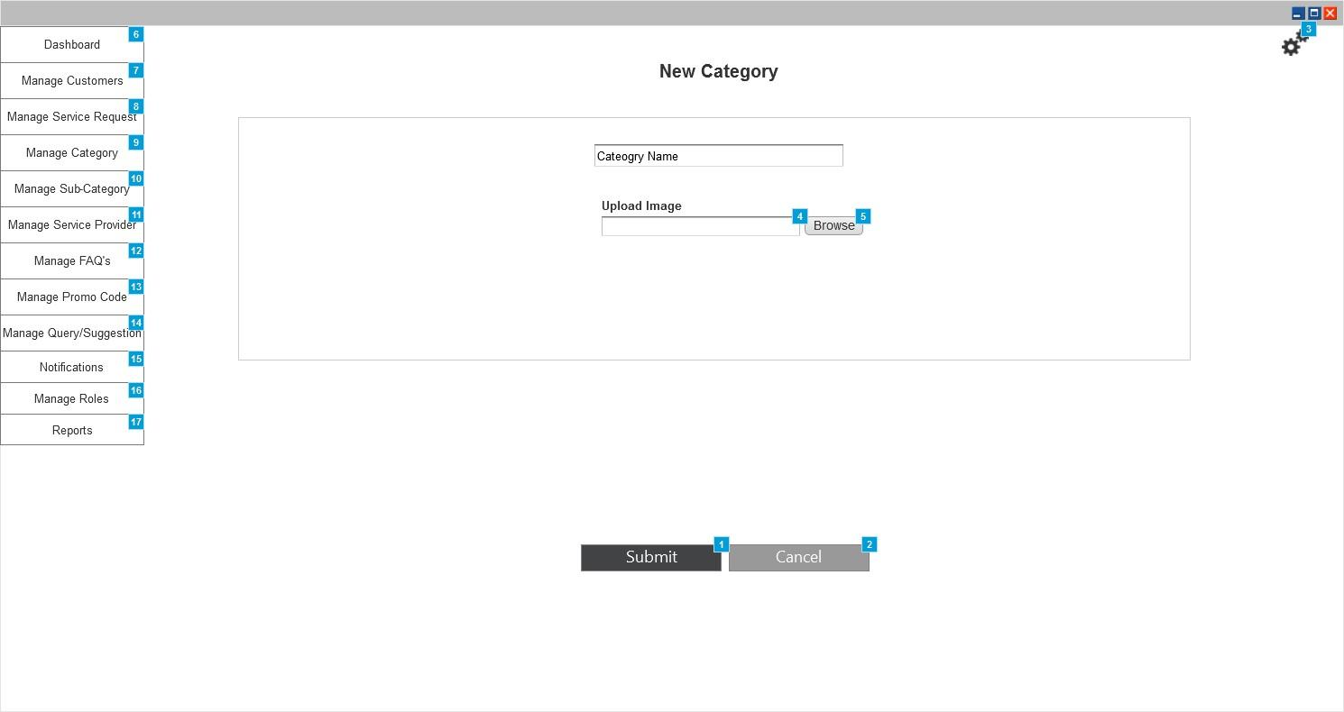

*Figure 75 New Category*

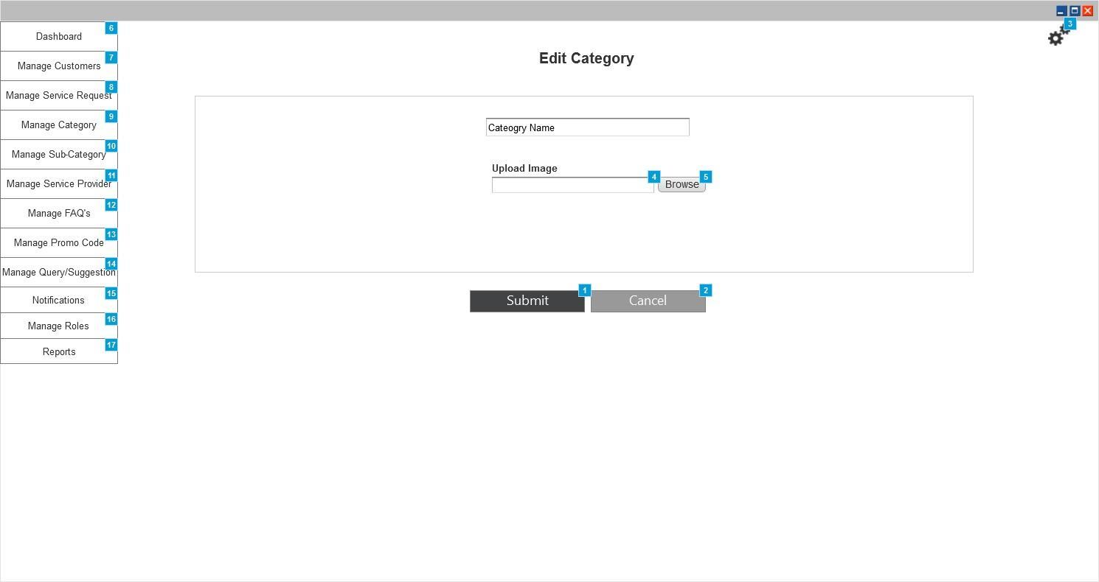

*Figure 76 Edit Category*

|  |  |  |
| --- | --- | --- |
| Actor(s) involved | Administrator | |
| Requirement definition | Administrator will be able to manage the categories to be shown on mobile application | |
| Pre-condition | Administrator has successfully logged into application and selected Manage Categories from menu | |
| Post-condition | Administrator will be able to view/add/edit/delete categories from this section | |
| Business process flow/Business Rules | ***Manage Categories***  Administrator will be able to view the list of existing categories in the application (as shown in figure 73). Category details will be arranged in the form of table where each line item will show following details:   1. Category ID 2. Date 3. Category Name 4. Action Buttons    1. View (Clicking this button will navigate admin to the view page explained below)    2. Edit (Clicking this button will navigate admin to the edit page explained below)    3. Delete (Clicking this button will delete the selected line item after confirmation).   Admin will be able to perform bulk delete actions by enabling checkbox against each item in the table and then clicking “Delete” menu item from the Action menu.  Admin can add new category manually by clicking “Add” menu item from the Action menu and then entering the details. Clicking “Add” menu will navigate admin to the new category page explained below.  ***View Category***  Admin will be able to view following details of the category on the view page:   1. Category Name 2. Category Image 3. History of changes done. Each history item will display the details like “Name of User, Date of changes done, Time of Changes done and Changed Value”.   ***Add Category***  Admin will be able to add new category manually by entering following details:   1. Category Name 2. Category Image   ***Edit Category***  Admin will be able to edit following details of the category:   1. Category Name 2. Category Image | |
| Field validation |  | |
|  | Category Name | Text Field |
|  | Category Image | Upload |
|  | Action | Menu |
|  | View | Button |
|  | Edit | Button |
|  | Delete | Button |
|  | Submit | Button |
|  | Cancel | Button |

### Manage Sub-Category

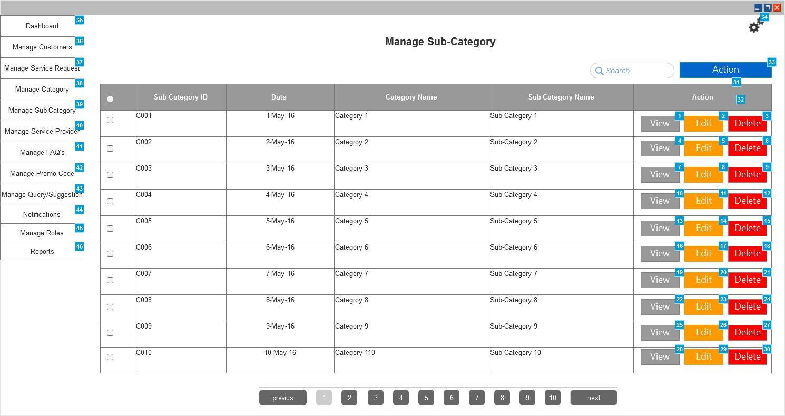

*Figure 77 Manage Sub-Category*

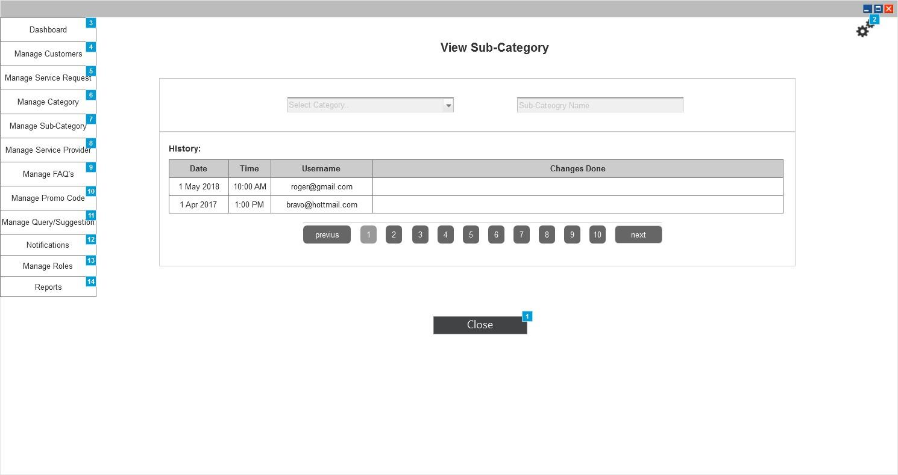

*Figure 78 View Service Provider*

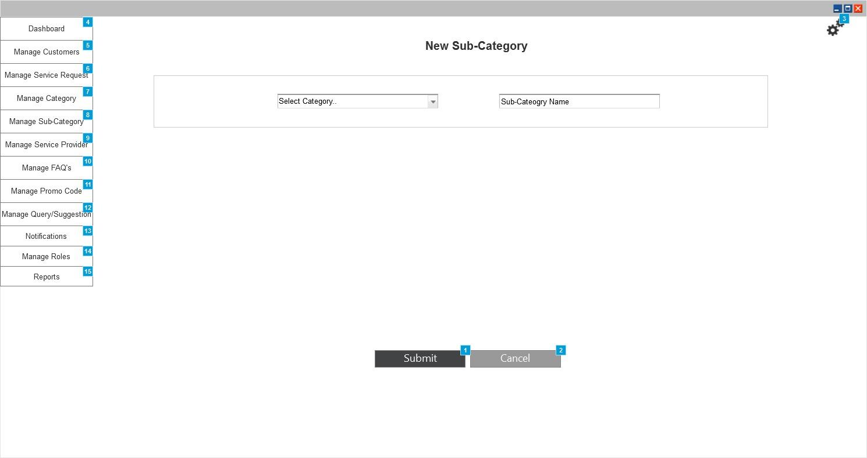

*Figure 79 New Sub-Category*

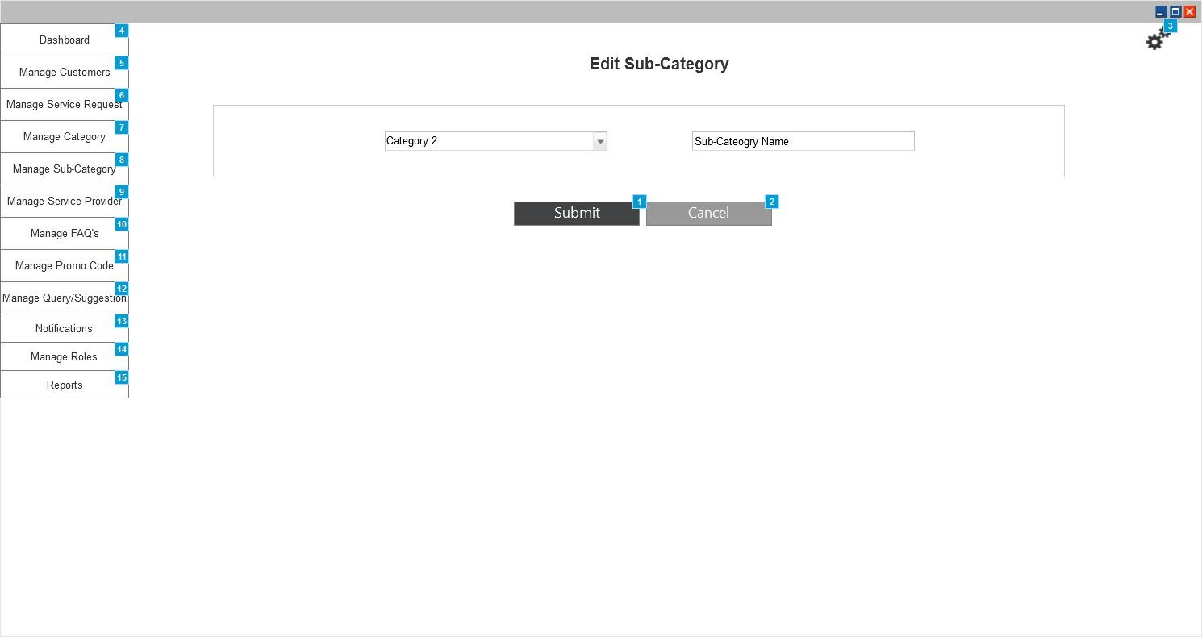

*Figure 80 Edit sub-Category*

|  |  |  |
| --- | --- | --- |
| Actor(s) involved | Administrator | |
| Requirement definition | Administrator will be able to manage the sub-categories to be shown on mobile application | |
| Pre-condition | Administrator has successfully logged into application and selected Manage Sub-Categories from menu. | |
| Post-condition | Administrator will be able to view/add/edit/delete sub-categories from this section | |
| Business process flow/Business Rules | ***Manage Sub-Categories***  Administrator will be able to view the list of existing sub-categories in the application (as shown in figure 77). Sub-Category details will be arranged in the form of table where each line item will show following details:   1. Sub-Category ID 2. Date 3. Category Name 4. Sub-Category Name 5. Action Buttons    1. View (Clicking this button will navigate admin to the view page explained below)    2. Edit (Clicking this button will navigate admin to the edit page explained below)    3. Delete (Clicking this button will delete the selected line item after confirmation).   Admin will be able to perform bulk delete actions by enabling checkbox against each item in the table and then clicking “Delete” menu item from the Action menu.  Admin can add new sub-category manually by clicking “Add” menu item from the Action menu and then entering the details. Clicking “Add” menu will navigate admin to the new sub-category page explained below.  ***View Category***  Admin will be able to view following details of the sub-category on the view page:   1. Category Name 2. Sub-Category Name 3. History of changes done. Each history item will display the details like “Name of User, Date of changes done, Time of Changes done and Changed Value”.   ***Add Category***  Admin will be able to add new sub-category manually by entering following details:   1. Category Name (select from list) 2. Category Image   ***Edit Category***  Admin will be able to edit following details of the sub-category:   1. Category Name 2. Sub-Category Name | |
| Field validation |  | |
|  | Category Name | Dropdown |
|  | Sub-Category Name | Text Field |
|  | Action | Menu |
|  | View | Button |
|  | Edit | Button |
|  | Delete | Button |
|  | Submit | Button |
|  | Cancel | Button |

### Manage FAQ’s

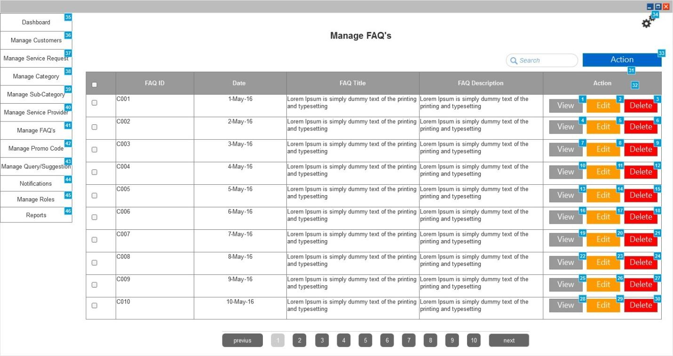

*Figure 81 Manage FAQ’s*

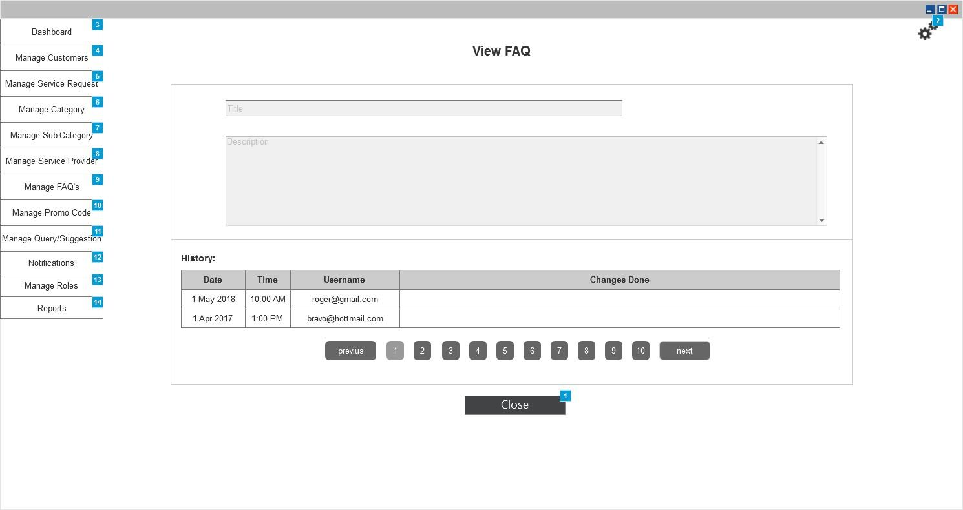

*Figure 82 View FAQ*

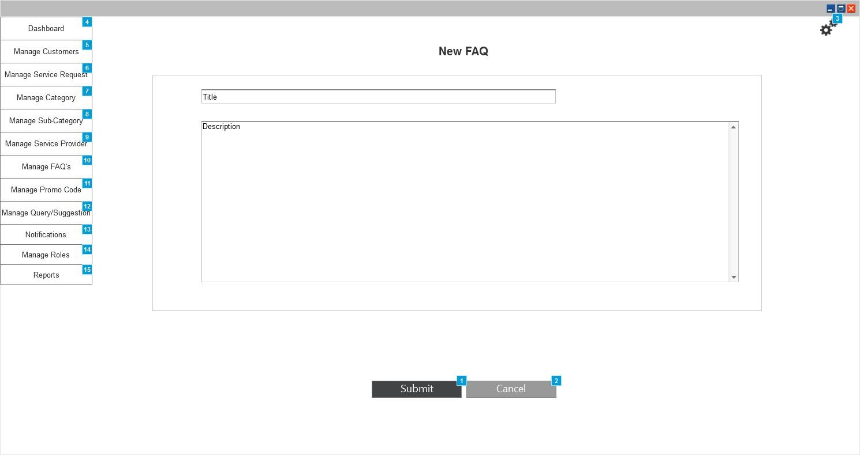

*Figure 83 New FAQ*

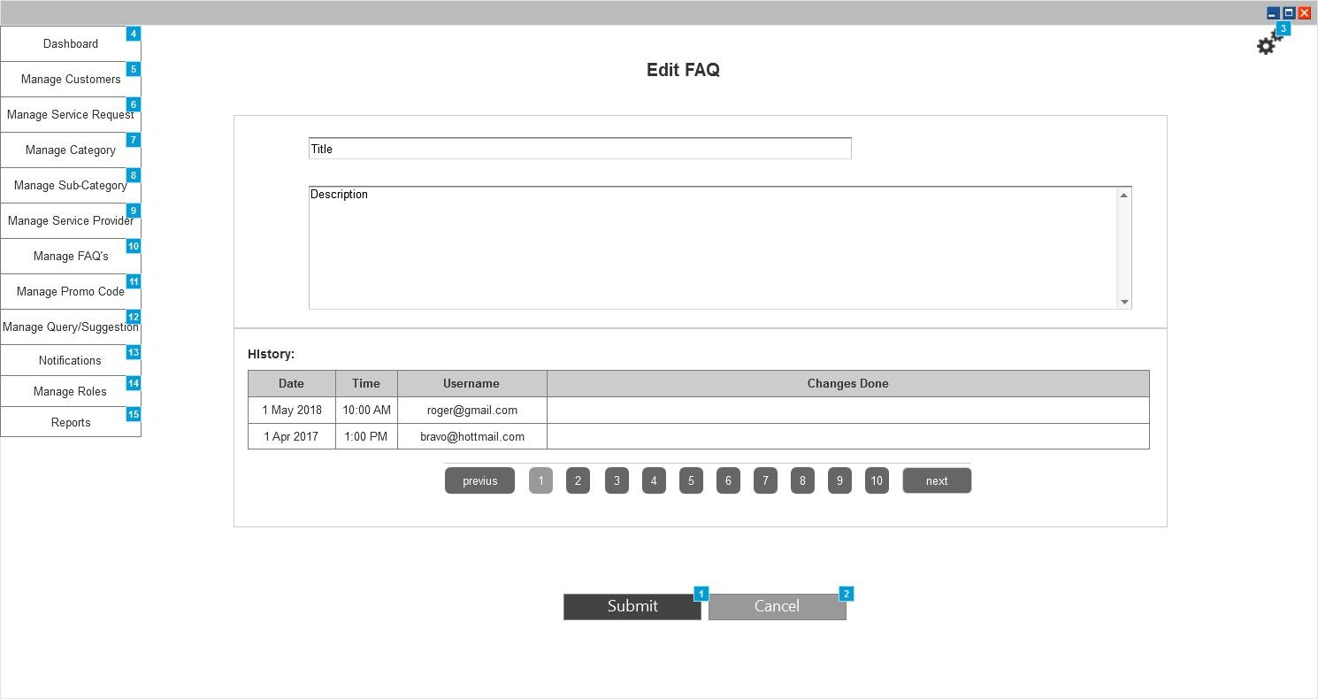

*Figure 84 Edit FAQ*

|  |  |  |
| --- | --- | --- |
| Actor(s) involved | Administrator | |
| Requirement definition | Administrator will be able to manage the FAQ’s to be shown on mobile application | |
| Pre-condition | Administrator has successfully logged into application and selected Manage FAQ from menu. | |
| Post-condition | Administrator will be able to view/add/edit/delete FAQ’s from this section | |
| Business process flow/Business Rules | ***Manage FAQ***  Administrator will be able to view the list of existing FAQ in the application (as shown in figure 81). FAQ details will be arranged in the form of table where each line item will show following details:   1. FAQ ID 2. Date 3. FAQ Title 4. FAQ Description 5. Action Buttons    1. View (Clicking this button will navigate admin to the view page explained below)    2. Edit (Clicking this button will navigate admin to the edit page explained below)    3. Delete (Clicking this button will delete the selected line item after confirmation).   Admin will be able to perform bulk delete actions by enabling checkbox against each item in the table and then clicking “Delete” menu item from the Action menu.  Admin can add new sub-category manually by clicking “Add” menu item from the Action menu and then entering the details. Clicking “Add” menu will navigate admin to the new FAQ page explained below.  ***View FAQ***  Admin will be able to view following details of the FAQ on the view page:   1. FAQ Title 2. FAQ Description 3. History of changes done. Each history item will display the details like “Name of User, Date of changes done, Time of Changes done and Changed Value”.   ***Add FAQ***  Admin will be able to add new FAQ manually by entering following details:   1. FAQ Title 2. FAQ Description   ***Edit FAQ***  Admin will be able to edit following details of the FAQ:   1. FAQ Title 2. FAQ Description | |
| Field validation |  | |
|  | FAQ Title | Text Field |
|  | FAQ Description | Text Area |
|  | Action | Menu |
|  | View | Button |
|  | Edit | Button |
|  | Delete | Button |
|  | Submit | Button |
|  | Cancel | Button |

### Manage Promo Code

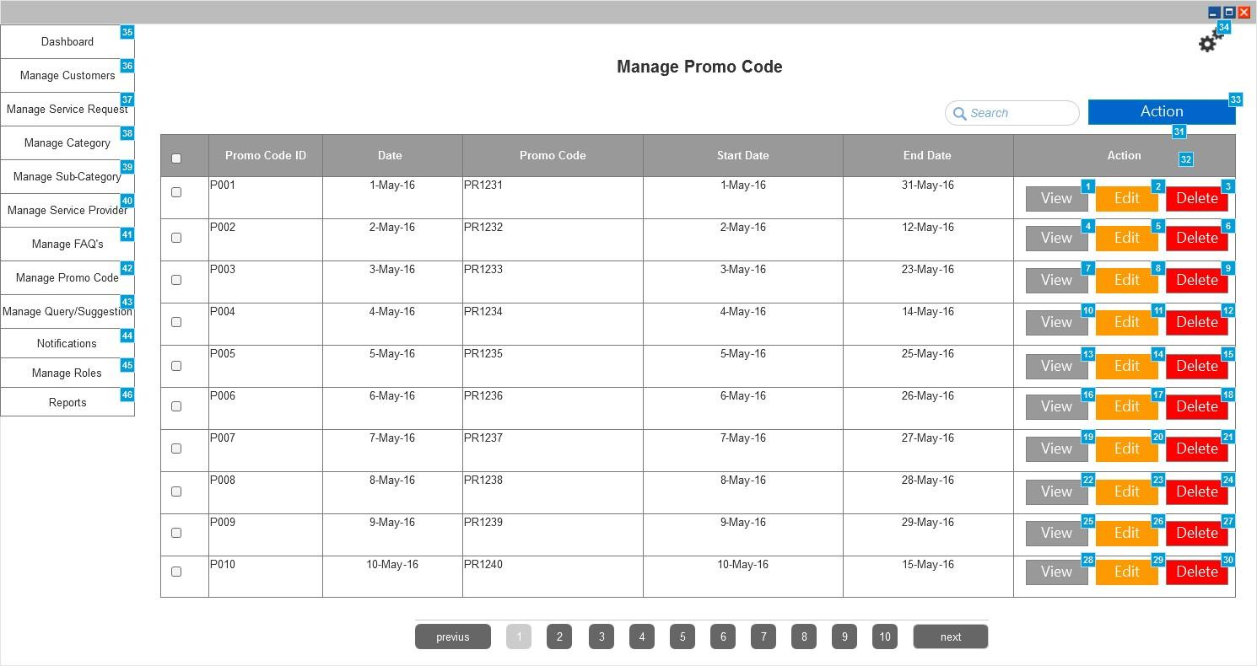

*Figure 85 Manage Promo Code*

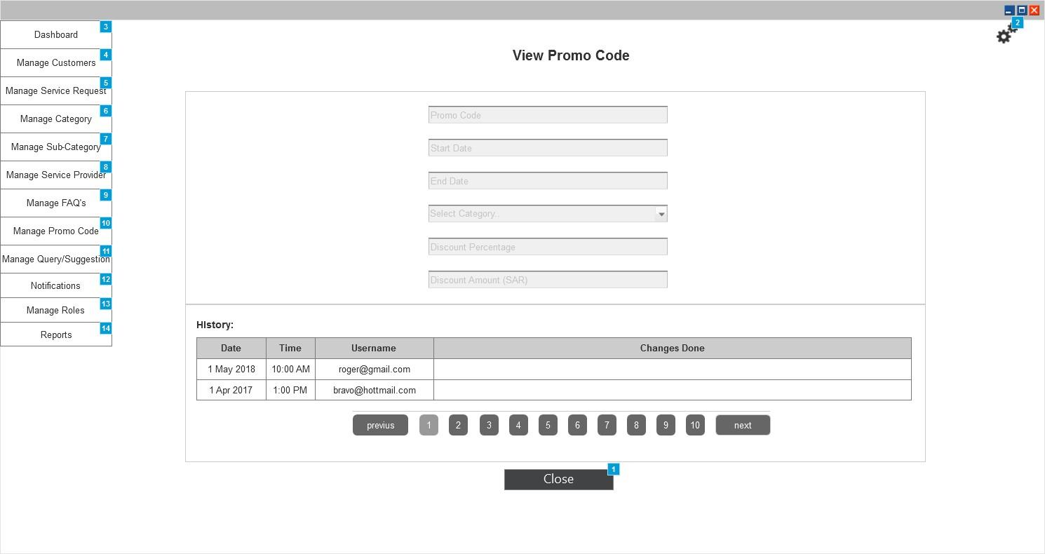

*Figure 86 View Promo Code*

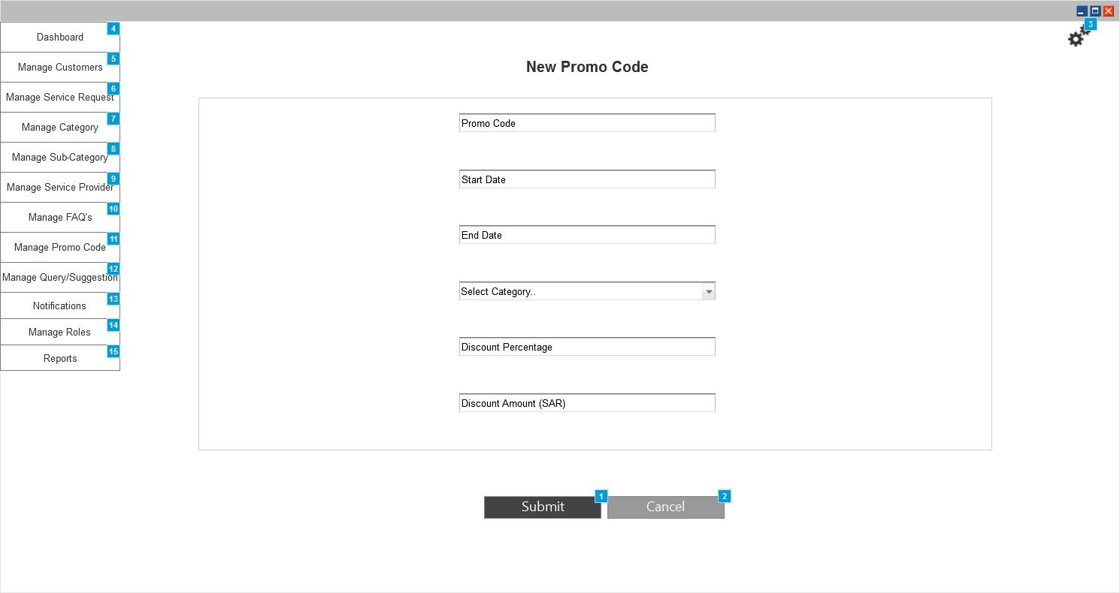

*Figure 87 New Promo Code*

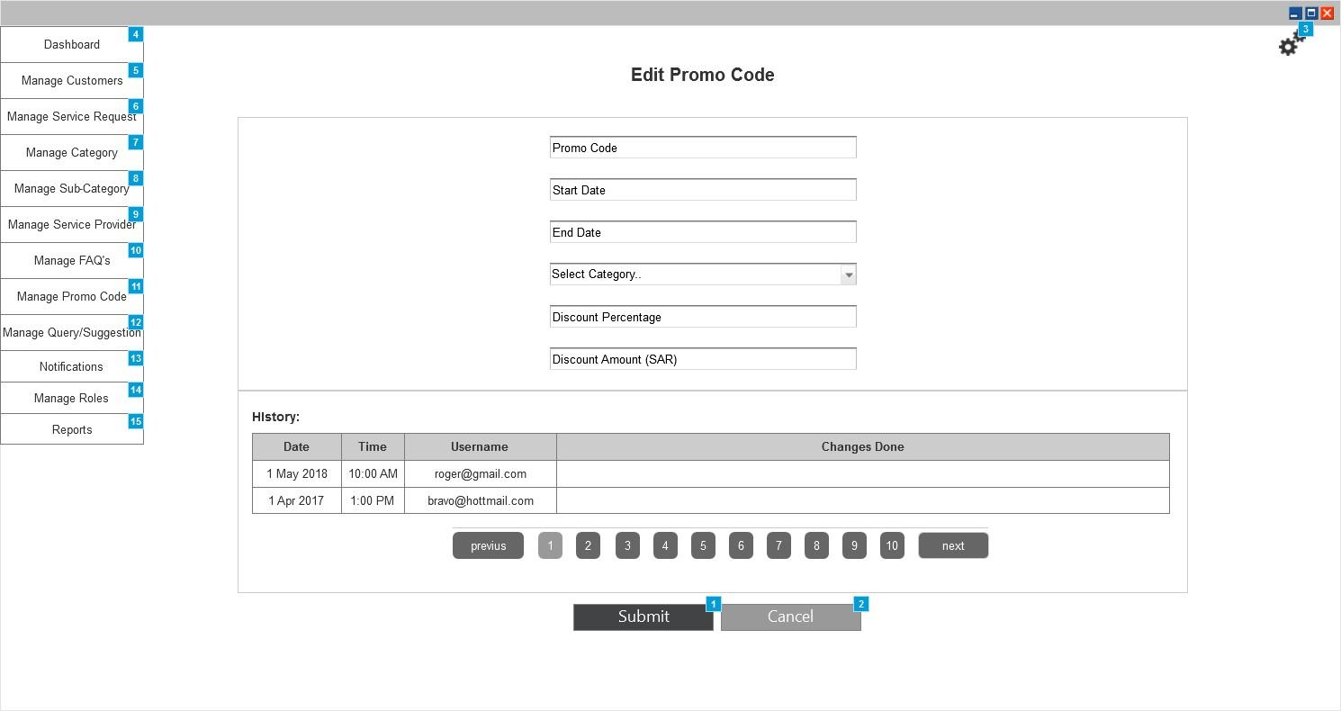

*Figure 88 Edit Promo Code*

|  |  |  |
| --- | --- | --- |
| Actor(s) involved | Administrator | |
| Requirement definition | Administrator will be able to manage the Promo codes to be used by the customers for discount while creating any service request. | |
| Pre-condition | Administrator has successfully logged into application and selected Manage Promo Code from menu. | |
| Post-condition | Administrator will be able to view/add/edit/delete Promo Code from this section | |
| Business process flow/Business Rules | ***Manage Promo Code***  Administrator will be able to view the list of existing Promo code in the application (as shown in figure 85). Promo code details will be arranged in the form of table where each line item will show following details:   1. Promo Code ID 2. Date 3. Promo Code 4. Start Date 5. End Date 6. Action Buttons    1. View (Clicking this button will navigate admin to the view page explained below)    2. Edit (Clicking this button will navigate admin to the edit page explained below)    3. Delete (Clicking this button will delete the selected line item after confirmation).   Admin will be able to perform bulk delete actions by enabling checkbox against each item in the table and then clicking “Delete” menu item from the Action menu.  Admin can add new promo code manually by clicking “Add” menu item from the Action menu and then entering the details. Clicking “Add” menu will navigate admin to the new Promo code page explained below.  Admin will generate the promo code and distribute over various social mediums which will then be used by customers to avail discount.  ***View Promo Code***  Admin will be able to view following details of the Promo Code on the view page:   1. Promo Code Text 2. Start Date 3. End Date 4. Category 5. Discount Percentage/Discount Amount (Admin can enter either value in percentage or actual amount) 6. History of changes done. Each history item will display the details like “Name of User, Date of changes done, Time of Changes done and Changed Value”.   ***Add Promo Code***  Admin will be able to add new Promo Code manually by entering following details:   1. Promo Code Text 2. Start Date 3. End Date 4. Category 5. Discount Percentage/ Discount Amount (Admin can enter either value in percentage or actual amount)   Promo code will be applicable within the date range selected and category selected. Promo code value will be shown in the quote details to the customer.  ***Edit Promo Code***  Admin will be able to edit following details of the Promo Code:   1. Promo Code Text 2. Start Date 3. End Date 4. Category 5. Discount Percentage / Discount Amount | |
| Field validation |  | |
|  | Promo Code | Text Field |
|  | Start Date | Date Picker |
|  | End Date | Date Picker |
|  | Category | Dropdown |
|  | Discount Percentage | Text Field |
|  | Discount Amount | Text Field |
|  | Action | Menu |
|  | View | Button |
|  | Edit | Button |
|  | Delete | Button |
|  | Submit | Button |
|  | Cancel | Button |

### Manage Query/Suggestion

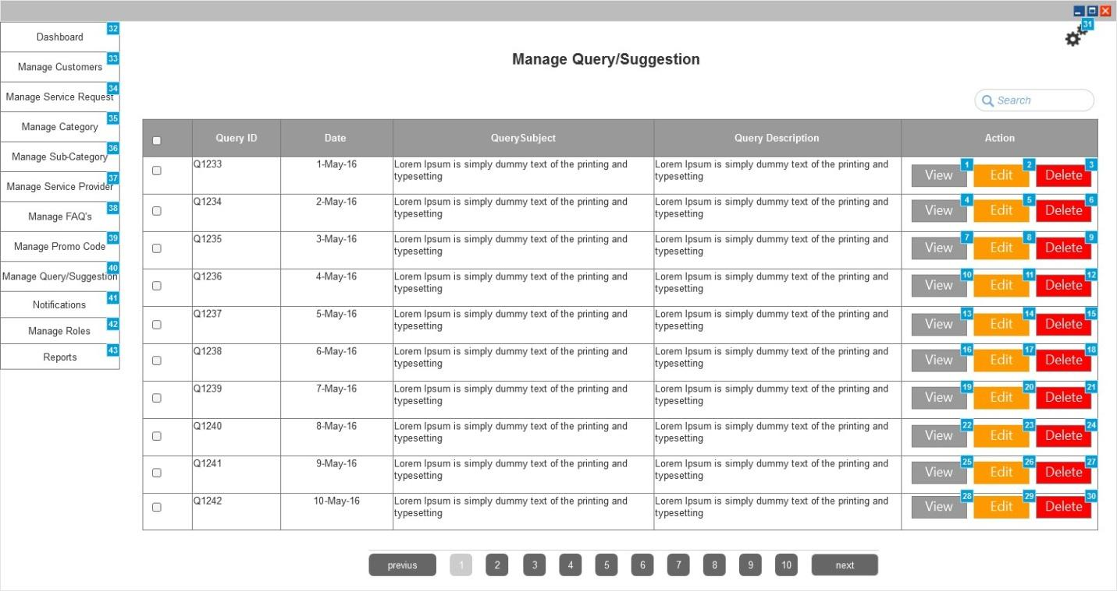

*Figure 89 Manage Query& Suggestion*

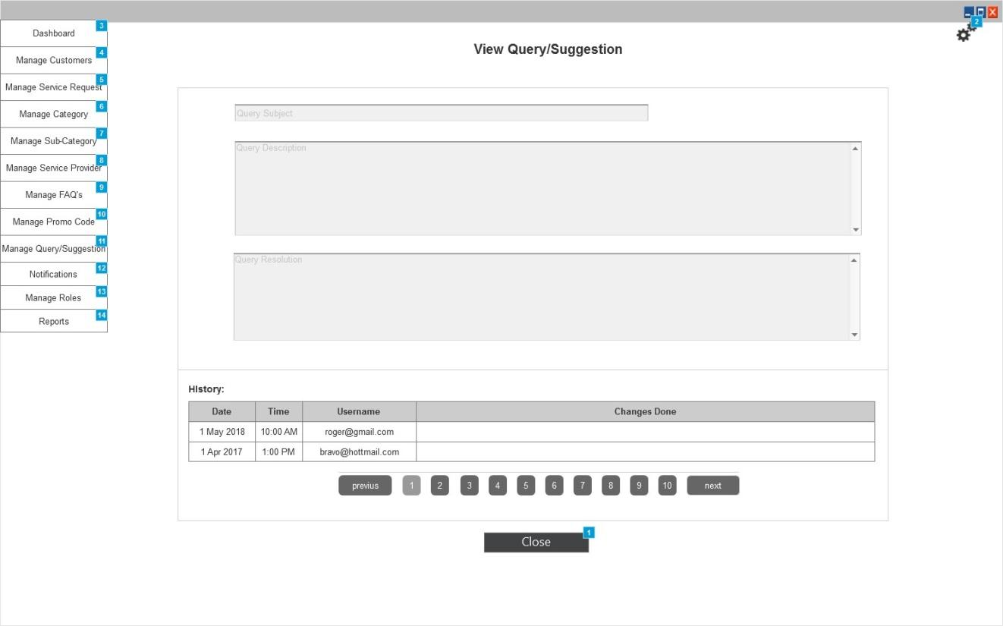

*Figure 90 View Query & Suggestion*

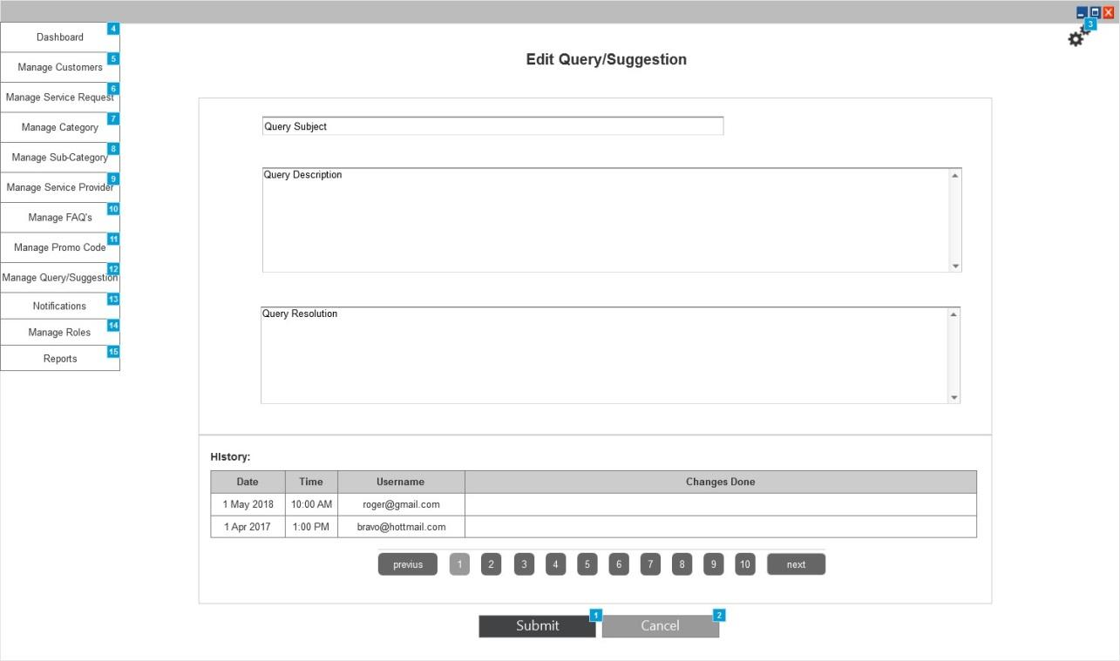

*Figure 91 Edit Query/Suggestion*

|  |  |  |
| --- | --- | --- |
| Actor(s) involved | Administrator | |
| Requirement definition | Administrator will be able to manage the query and suggestion sent by the customer using the contact form. | |
| Pre-condition | Administrator has successfully logged into application and selected Manage Query/Suggestion from menu. | |
| Post-condition | Administrator will be able to view and reply to the query/suggestion sent by customer/service provider. | |
| Business process flow/Business Rules | ***Manage Query/Suggestion***  Administrator will be able to view the list of query/suggestion sent by the customer/service advisor (as shown in figure 89). Query/Suggestion details will be arranged in the form of table where each line item will show following details:   1. Query ID 2. Date 3. Query Subject 4. Query Description 5. Action Buttons    1. View (Clicking this button will navigate admin to the view page explained below)    2. Edit (Clicking this button will navigate admin to the edit page explained below)    3. Delete (Clicking this button will delete the selected line item after confirmation).   Admin will be able to perform bulk delete actions by enabling checkbox against each item in the table and then clicking “Delete” menu item from the Action menu.  ***View Query/Suggestion***  Admin will be able to view following details of the Query sent by customer/service provider and resolution given by them on view page:   1. Query Subject 2. Query Description 3. Query Resolution 4. History of changes done. Each history item will display the details like “Name of User, Date of changes done, Time of Changes done and Changed Value”.   ***Edit Query/Suggestion***  Admin will be able to edit the query or reply to the query by entering their resolution in the provided field. Entering the resolution will send the details as push notification and will be shown on the contact screen as accordion to customer/service provider. | |
| Field validation |  | |
|  | Query Subject | Text Field |
|  | Query Description | Text Area |
|  | Query Resolution | Text Area |
|  | Action | Menu |
|  | View | Button |
|  | Edit | Button |
|  | Delete | Button |
|  | Submit | Button |
|  | Cancel | Button |

### Notifications

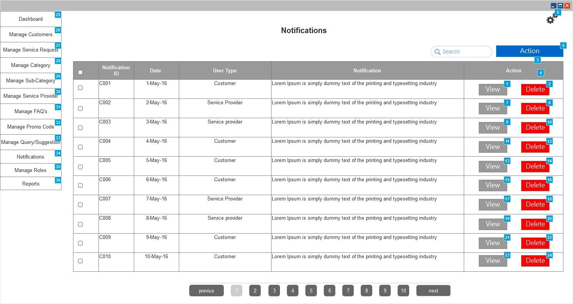

*Figure 92 Manage Notifications*

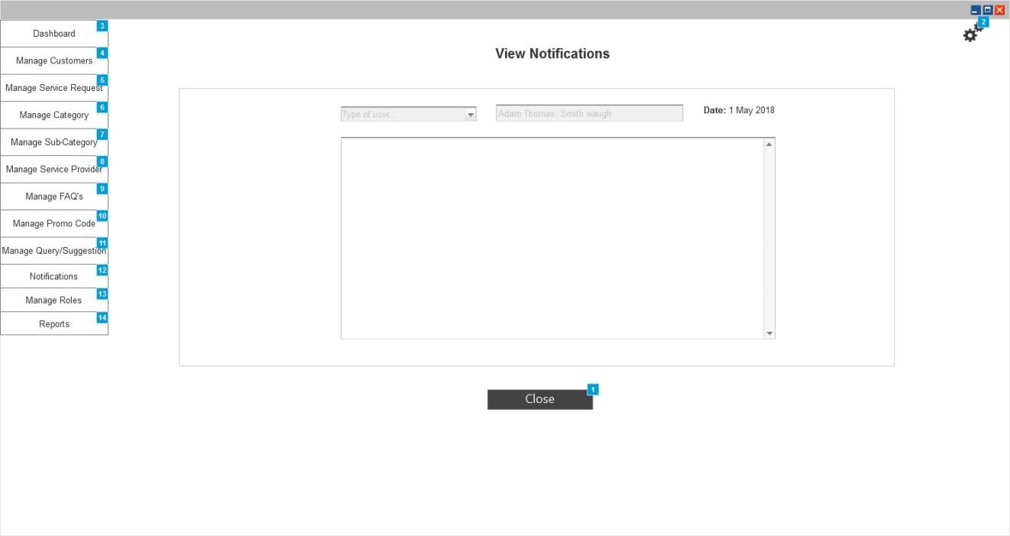

*Figure 93 View Notification*

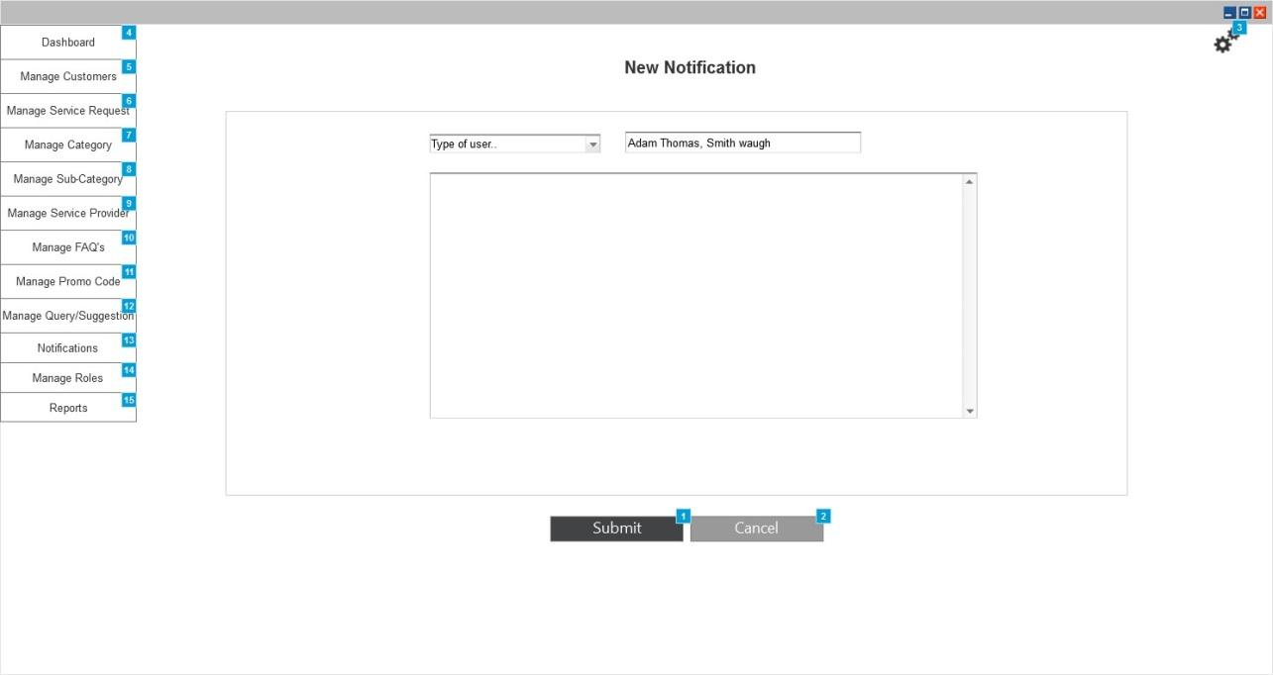

*Figure 94 New Notification*

|  |  |  |
| --- | --- | --- |
| Actor(s) involved | Administrator | |
| Requirement definition | Administrator will be able to manage the notifications to be sent. | |
| Pre-condition | Administrator has successfully logged into application and selected Notifications from menu. | |
| Post-condition | Administrator will be able to view and create new notifications to be send to the users | |
| Business process flow/Business Rules | ***Manage Notifications***  Administrator will be able to view the list of notifications created by them (as shown in figure 92). Notification details will be arranged in the form of table where each line item will show following details:   1. Notification ID 2. Date 3. User Type 4. Notification Details. 5. Action Buttons    1. View (Clicking this button will navigate admin to the view page explained below)    2. Delete (Clicking this button will delete the selected line item after confirmation).   Admin will be able to perform bulk delete actions by enabling checkbox against each item in the table and then clicking “Delete” menu item from the Action menu.  Admin can create new notification by clicking “Add” menu item from the Action menu and then entering the details. Clicking “Add” menu will navigate admin to the new notifications page explained below.  ***View Notifications***  Admin will be able to view following details of the notifications sent by them to all users:   1. Type of Users 2. List of Users (It will show username/names of user to whom the notification is sent) 3. Date of creation 4. Notification Description   ***New Notification***  Admin will be able to create new notification by entering following details:   1. Type of Users (Admin can select any type of user or all users. Selecting any user type will suggest/show only the names within that particular user type. Selecting “All” will show all users in the List of user field) 2. List of Users (Admin can search and select the name of user to whom the notification is to be sent. If not selected then notification will be sent to all users within that user type). 3. Notification Description (Its free text field)   Submitting the details will send push notification and email notification to the users selected. Since its notification it will not have feature to edit notification. | |
| Field validation |  | |
|  | Type of User | Dropdown |
|  | List of user | Text Field |
|  | Notification Description | Text Area |
|  | Action | Menu |
|  | View | Button |
|  | Delete | Button |
|  | Submit | Button |
|  | Cancel | Button |

### Manage Roles

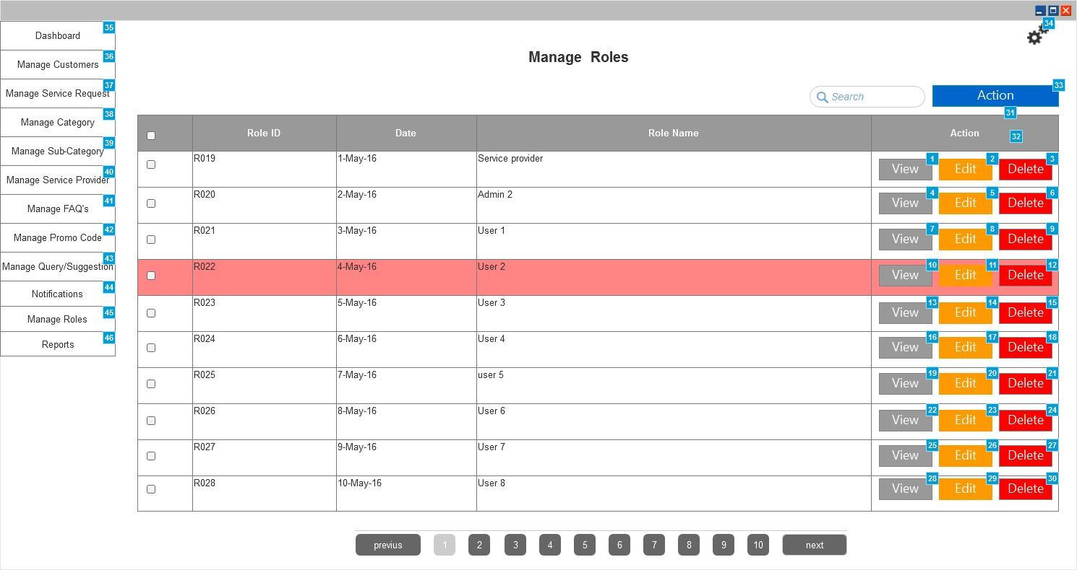

*Figure 95 Manage Roles*

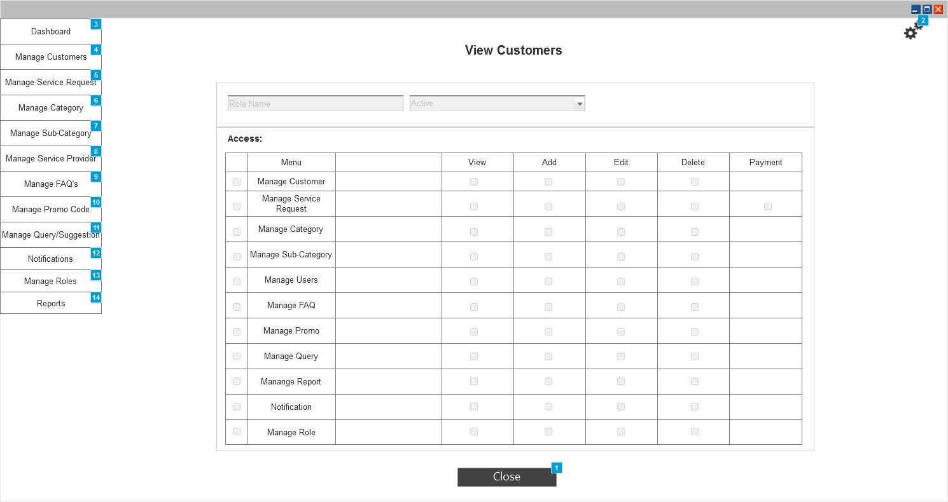

*Figure 96 View Roles*

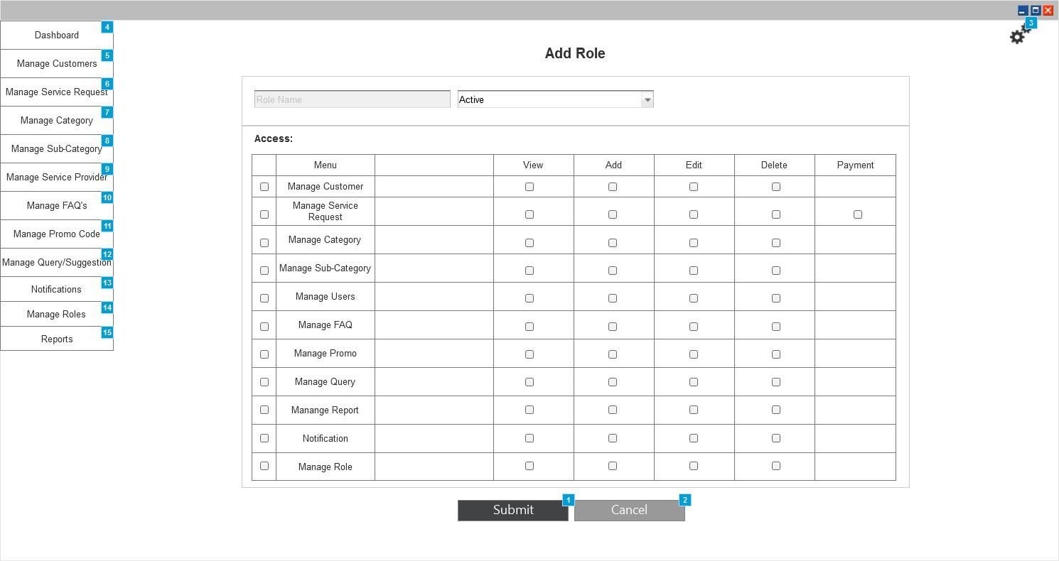

*Figure 97 New Role*



*Figure 98 Edit Role*

|  |  |  |
| --- | --- | --- |
| Actor(s) involved | Administrator | |
| Requirement definition | Administrator will be able to manage the roles. These roles will be able to access using only web based panel. | |
| Pre-condition | Administrator has successfully logged into application and selected Manage Roles from menu | |
| Post-condition | Administrator will be able to view/add/edit/delete roles from this section | |
| Business process flow/Business Rules | ***Manage Roles***  Administrator will be able to view the list of existing roles in the application (as shown in figure 95). Role details will be arranged in the form of table where each line item will show following details:   1. Role ID 2. Date 3. Role Name 4. Action Buttons    1. View (Clicking this button will navigate admin to the view page explained below)    2. Edit (Clicking this button will navigate admin to the edit page explained below)    3. Delete (Clicking this button will delete the selected line item after confirmation).   Admin will be able to perform bulk delete actions by enabling checkbox against each item in the table and then clicking “Delete” menu item from the Action menu.  Admin can add new role by clicking “Add” menu item from the Action menu and then entering the details. Clicking “Add” menu will navigate admin to the new role page explained below.  Any role made inactive will be shown with red highlight.  ***View Role***  Admin will be able to view following details of the roles on the view page:   1. Role Name 2. Status (Active/Inactive) 3. Access level    1. Access level will show the list of menu items and action items accessible to the selected role. Only the menu items and action items checked will be visible to the selected role. 4. History of changes done. (Each history item will display the details like “Name of User, Date of changes done, Time of Changes done and Changed Value”.)   ***Add Role***  Admin will be able to add new role by entering following details:   1. Role Name 2. Status (Active/Inactive) 3. Access Level (Admin can select the menu items and action buttons accessible to the role by enabling the check box against them. The menu items are displayed below the “menu” column and action items are shown below the “View, edit, delete, new and payment” columns).   ***Edit Role***  Admin will be able to edit following details of the role:   1. Role Name 2. Status 3. Access Level | |
| Field validation |  | |
|  | Role Name | Text Field |
|  | Status | Dropdown |
|  | Access Level | Checkbox |
|  | Action | Menu |
|  | View | Button |
|  | Edit | Button |
|  | Delete | Button |
|  | Submit | Button |
|  | Cancel | Button |

### Reports

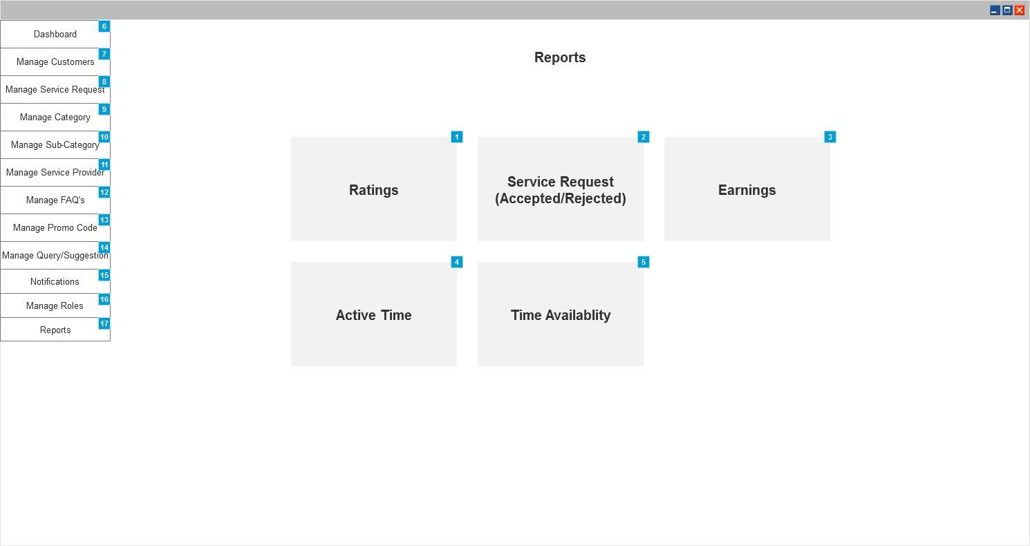

*Figure 99 Reports*

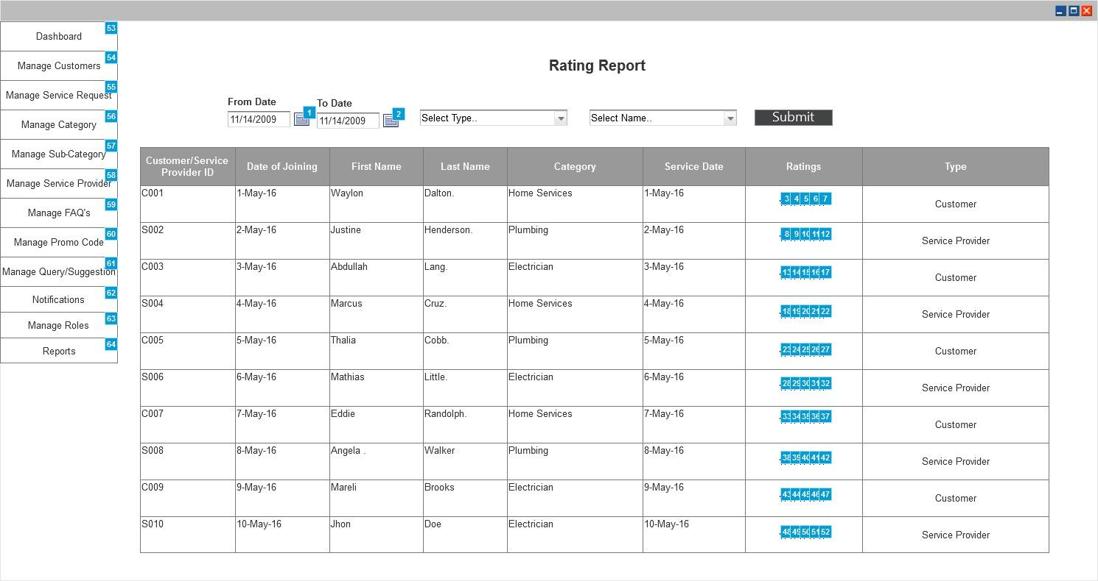

*Figure 100 Ratings report*

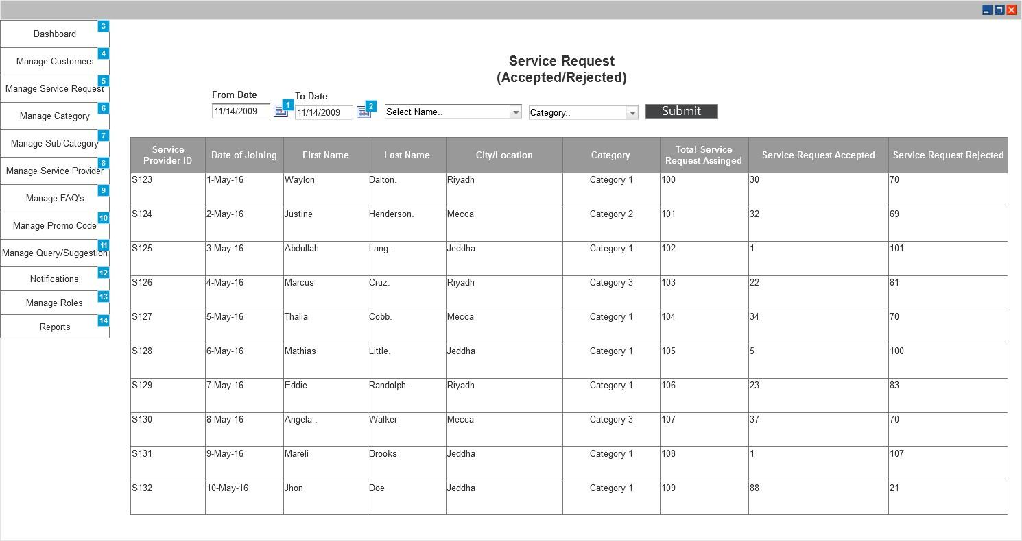

*Figure 101 Service Report*

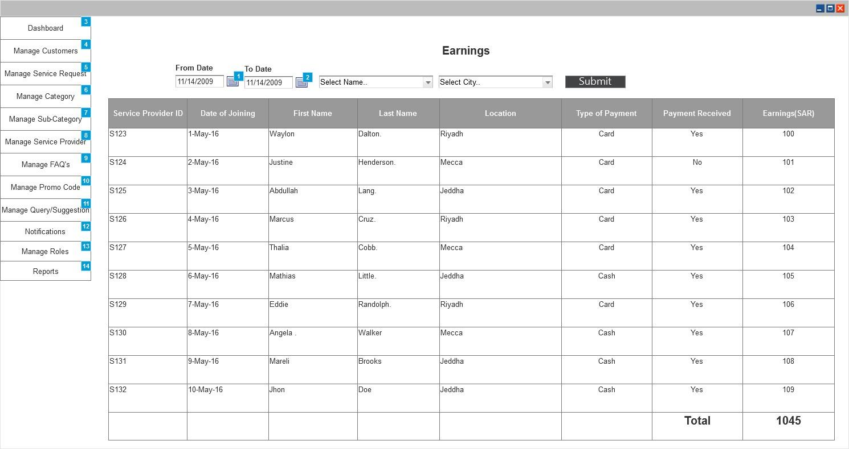

*Figure 102 Earning Report*



*Figure 103 Active Time Report*

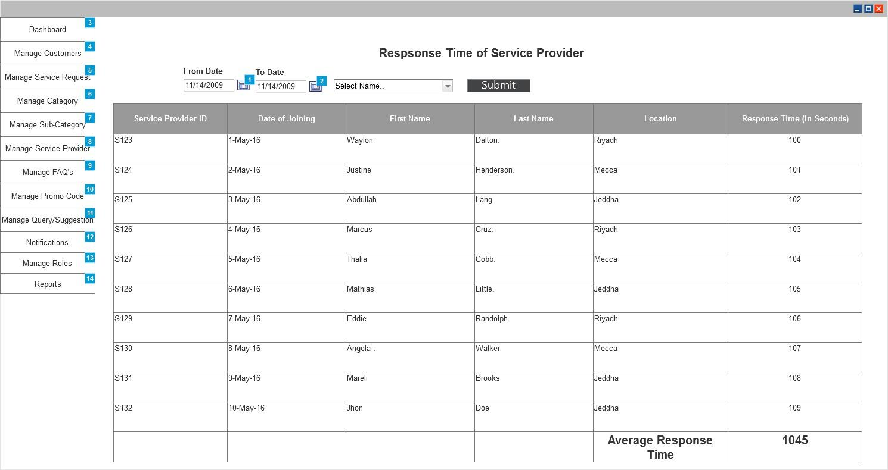

*Figure 104 Response Time Report*

|  |  |  |
| --- | --- | --- |
| Actor(s) involved | Administrator | |
| Requirement definition | Administrator will be able to generate various reports. | |
| Pre-condition | Administrator has successfully logged into application and selected Reports from menu | |
| Post-condition | Administrator will be able to generate repots like Rating, Service Request, Earnings, Active Time and Response Time. | |
| Business process flow/Business Rules | ***Rating Report***  Rating report will allow administrator to view reports of any customer or service provider (as shown in figure 100). Administrator will be able to filter and view report using following inputs:     1. Date Range (Admin can view ratings report within any particular date range by selecting From date and To date) 2. Type of User (Admin can filter the ratings based on the user i.e. customer or service provider. Selecting any user type will show results only for selected user type). 3. Name (Admin can view ratings for any particular user by selecting any user name using this menu).   Report will show details like “Customer Id/Service Provider ID, Date, First Name, Last name, Category, Service date, Ratings and Type of User”.  ***Service Request***  Service request report will allow administrator to view number of request assigned to the service provider, number of request accepted by service provider and number of request rejected by service provider (as shown in figure 101) . Administrator will be able to filter the report by using following inputs:   1. Date Range (Admin can view service request report within any particular date range by selecting From date and To date) 2. Name (Admin can view service report for any particular service provider by selecting any user name using this menu). 3. Category (Admin can view service report for any particular category by selecting the category name from this menu)   Report will show details like “Service Provider ID, Date, First Name, Last name, City, Category, Total Service Request Assigned, Total Service request accepted and Total service request rejected”.  ***Earnings***  Earnings report will allow administrator to view revenue generated by each service provider and total revenue generated (as shown in figure 102). Administrator will be able to filter the report by using following inputs:   1. Date Range (Admin can view earnings report within any particular date range by selecting From date and To date) 2. Name (Admin can view earning report for any particular service provider by selecting any user name using this menu). 3. City (Admin can view earning report for any particular city by selecting the city name from this menu)   Report will show details like “Service Provider ID, Date, First Name, Last name, City, Category, Type of payment, Payment Received (Yes/No) and Earnings for each service provider (in SAR) and Total earnings”.  Admin can also view the collective report of earnings, deposit and pending amount by service provider in “Earning by service provider report”.  ***Active Time***  Active time report will allow administrator to view the time spent by service provider on work and on mobile application (as shown in figure 103). Administrator will be able to filter the report by using following inputs:   1. Date Range (Admin can view active time report within any particular date range by selecting From date and To date) 2. Name (Admin can view active time report for any particular service provider by selecting any user name using this menu). 3. Category (Admin can view active time report for any particular category by selecting the category name from this menu)   Report will show details like “Service Provider ID, Date, First Name, Last name, City, Active time of work and Active time on application”.  ***Response Time***  Response time report will allow administrator to view the average time taken by service provider to respond any request created by customer (as shown in figure 104). Administrator will be able to filter the report by using following inputs:   1. Date Range (Admin can view response time report within any particular date range by selecting From date and To date) 2. Name (Admin can view active time report for any particular service provider by selecting any user name using this menu).   Report will show details like “Service Provider ID, Date, First Name, Last name, City, and Average response time in seconds”. | |
| Field validation |  | |
|  | From date | Date Picker |
|  | To date | Date Picker |
|  | City | Dropdown |
|  | Name | Dropdown |
|  | Category | Dropdown |
|  | Submit | Button |

# ASSUMPTIONS

1. The end-user must have adequate internet connectivity and compatible device mentioned above in operating environment section.
2. The client will purchase as a third party API (Twilio/Bulksms and Payfort Payment gateway) which are required for the development of the System and we will integrate it with the proposed web application.
3. Mobile application will be developed in cross platform technologies.
4. Web based backend will be developed in PHP and the designs will be done using ready admin templates.
5. Client already has Google and Apple developer accounts.
6. Client will provide server setup, domain name and SSL Certificate.
7. Client will provide PCI compliance certification and details.
8. Application will be available in English and Arabic language only.

# CONSTRAINTS

1. Web Panel for Administrator will be in English Language only.
2. Mobile application will be in English and Arabic. For Arabic content admin will need to enter information for Arabic and English simultaneously considering each Input field.
3. Any Address in the input field will be displayed using Google Maps/Places API.

# NON FUNCTIONAL REQUIRMENTS

Non-functional requirements include performance requirements, security requirements and portability requirements.

## Technical Specifications

Following environment infrastructure will be required during and after the development.

|  |  |
| --- | --- |
| Deployment Location ** | Client will take care of deployment environment and will give the hosting credentials. |
| Repository Location | Development builds will be stored in the SVN/ GIT repository available in the NeoSOFT infrastructure. |
| Development Location | Developer’s terminal at NeoSOFT |
| Staging Location | It will be deployed at the NeoSOFT’s development location and same will be shared with the client during the development |

** Only after the realization of the final payment, we will be moving the development to this location.

## Technology Details:

**Development Tools**

Mobile Application:

Android/iOS: Ionic 3

Web Application:

PHP

**Design Tools:**

Adobe Photoshop

HTML/ CSS

**Database:**

My SQL

## Operating Environment

The proposed mobile application will be compatible with following OS

|  |  |  |
| --- | --- | --- |
| **Device** | **OS** | **Version** |
| Smartphone | Android | V4.4 and above |
| iPhone | iOS | V9 and above |

## Communication Interface

User mobile should connect with Internet using HTTP/HTTPS protocol.

Administrator web based panel on Internet will be using HTTP/HTTPS protocol.

## Performance Requirements

1. This software will have web-based backend and requires a powerful server machine with high band internet access.
2. Server should have a powerful CPU and high speed internet access so that it can handle multiple users at the same time. Another performance requirement is the storage space.
3. Higher storage space means more user and bigger work-space per user so higher the storage, better the performance.
4. Performance requirement by the user side is, mobile application and web services should be developed as a lightweight so that it can work on almost any platform even with slower internet connections.
5. High availability is required
6. Data integrity is of critical importance.
7. Expected number of simultaneous user should be at least 1,000,000. System should be able to deal with users at the same time. Also database of the system should handle at least a thousand of users at any periods.

## Security Requirements

1. Product should be able to protect privacy of user data.
2. Work-space of the user should only be accessed through user own credentials and any other user should not be able to access the user private data.
3. Since execution will also be done in the machine in the cloud, user should be restricted in terms of user rights.
4. User should only access to his own work-space and should not access to any other work-space with the programs they run on the cloud. Also, rights of the user should be restricted so that user cannot harm to system by the programs they run or by the commands they run on terminal.
5. Since all the data will be transferred on the web, system should also use an encryption and decryption mechanism only intended user can decode the data and work on the data.

## Portability Requirements

1. Main purpose of developing web & mobile based IDE is to improve the portability of software development process.
2. To improve portability, software should run on smart phones and iPhones with variety of connection speeds.
3. As explained in the performance requirements section, software should be lightweight so that it can run on a machine with slow internet connection. To make the backend application lightweight, simple libraries and tools should be used at developing phase. Such as using JavaScript and HTML5 instead of Apache Flex whereas use of latest iconic framework to develop mobile application should be considered.
4. Portability also means running on most number of different platform without an additional effort. To achieve this, web application should be developed by using the common technologies and tools which are provided by all common web browsers and operating system such as HTML5, JQuery etc. Whereas mobile application will be developed using cross-platform technologies like ionic 3 to maintain single code base and easy deployment on Android and iOS platforms.

## GREY AREAS

1. Mapping/Integration of any External Software will need additional efforts.

2. Any External Hardware integration will need additional efforts.

## Process Flow Diagrams

### Functional Flow

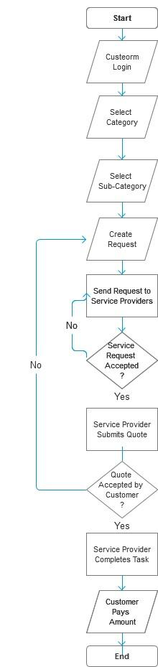

## Supported gateways:

1. BulkSms/Twilio.
2. Payfort payment gateway